WV User Preferences

Web Reimbursement Preferences – Current
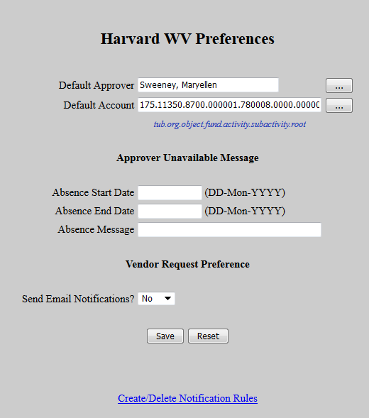

New Look
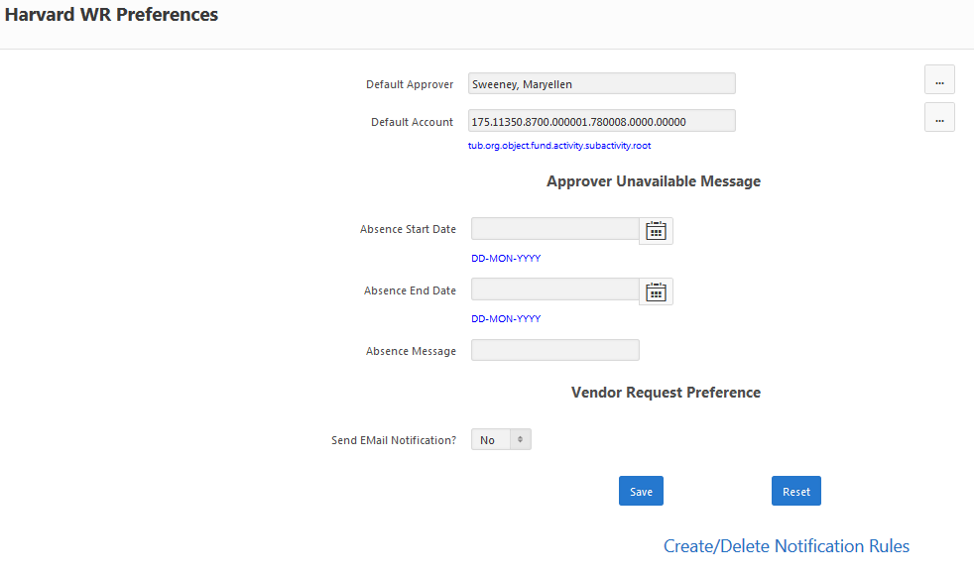

Changes:
- Absence Date Search using pop-up calendars

Reimbursement Email Maintenance - Current
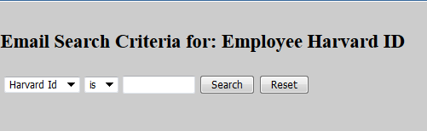

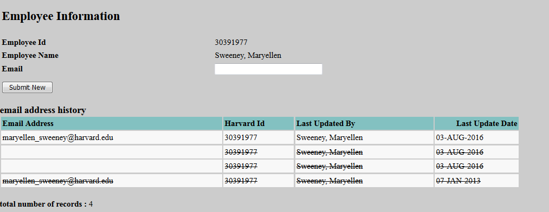

New Look
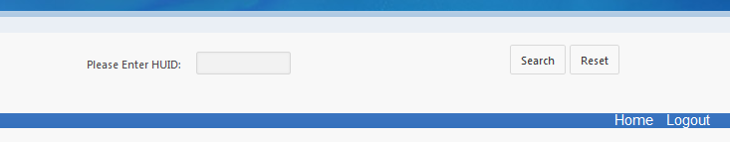

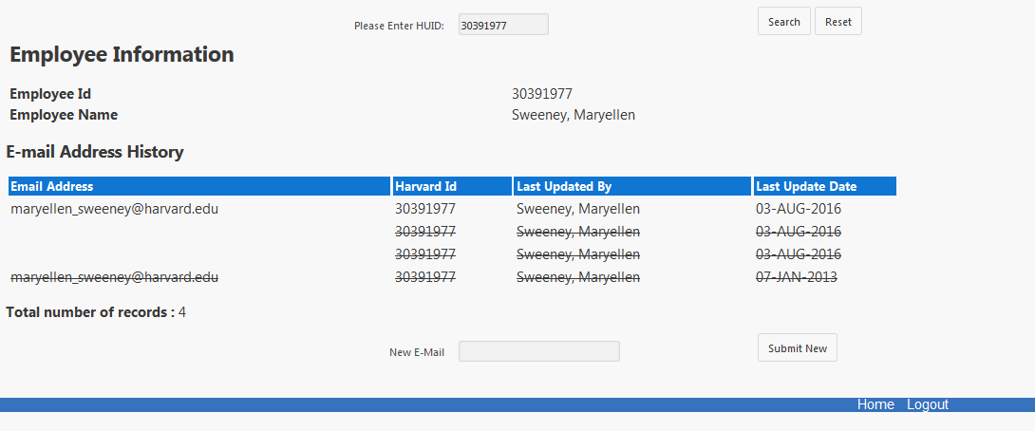

Reimbursement Email Maintenance - Current

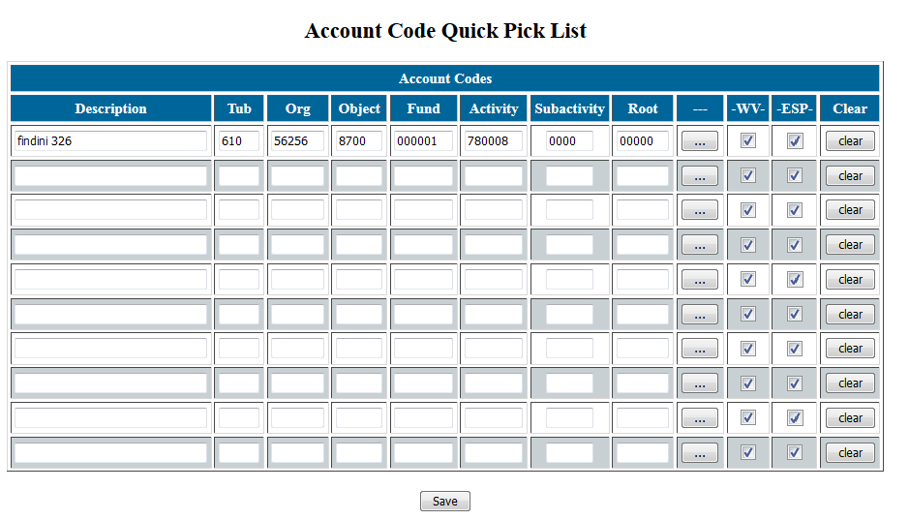

New Look
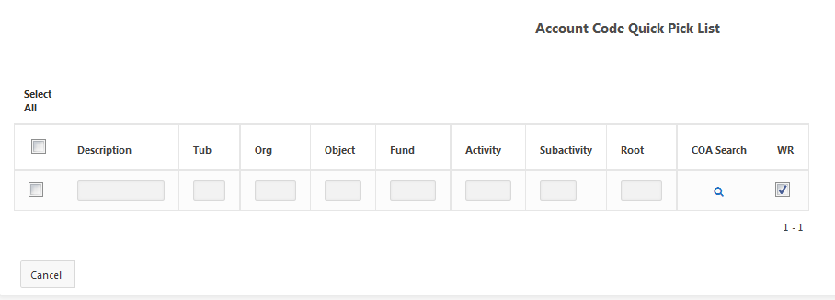

Changes:
- Clear buttons and ESP fields have been removed
- Ability to add additional rows
- Ability to Select lines and Delete rows
- Ability to Select All and Delete all rows
- Save/Delete functions will provide message to show action completed

