FINDINI 4.0.10 Training Tips for PCARD:
Users will see some noticeable visual differences within the HRVD^PCard^Local Admin responsibility and menus. The following items will be updated in the HRVD^PCard^Local Admin responsibility:
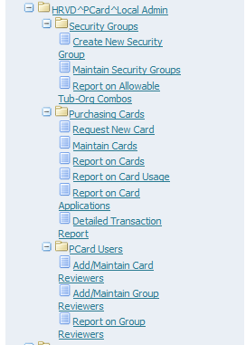
Please note that the rest of the Web Reimbursement functions (such as Create Reimbursement) and the PCard Reviewer responsibility will be completed in the May 2017 FINDINI 4.0.11 release.
PCard Local Administrator
Below are a few screenshots illustrating the new look and feel, and some notes of changes you will see delivered in this October FINDINI release.

Create a New Security Group
New Look
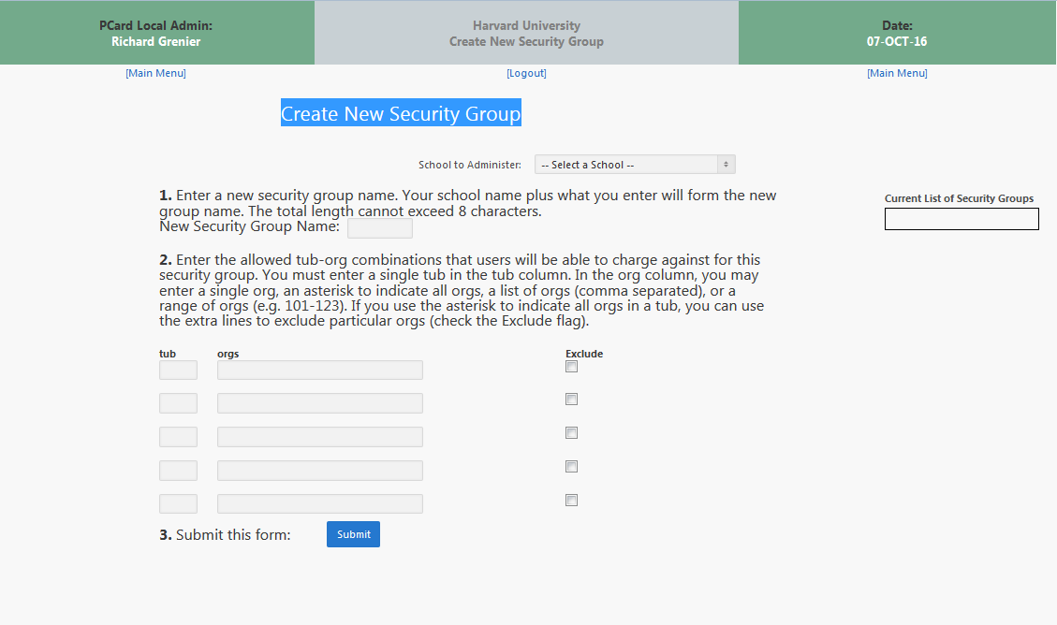
Changes:
- ‘School to Administer’ is built within the form and is now a drop down
- Slight change to the header information
- No repeat of menu functions at bottom of form

Maintain Security Groups
Changes:
- ‘School to Administer’ is built within the form and is now a drop down
- Slight change to the header information
- No repeat of menu functions at bottom of form

Report on Allowable Tub – Org Combinations
New Look
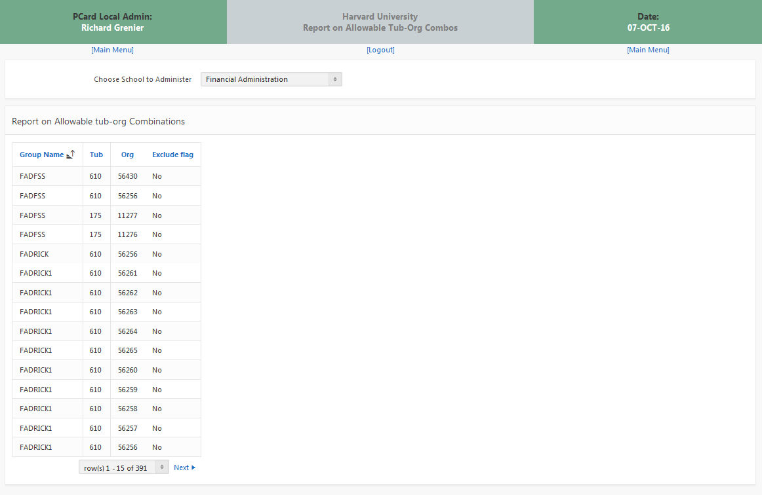
Changes:
- ‘School to Administer’ is built within the form and is now a drop down
- Slight change to the header information
- No repeat of menu functions at bottom of form
- Ability to Sort
- Addition of ‘per page’ results (rather than long page)

Request a New Card
New Look
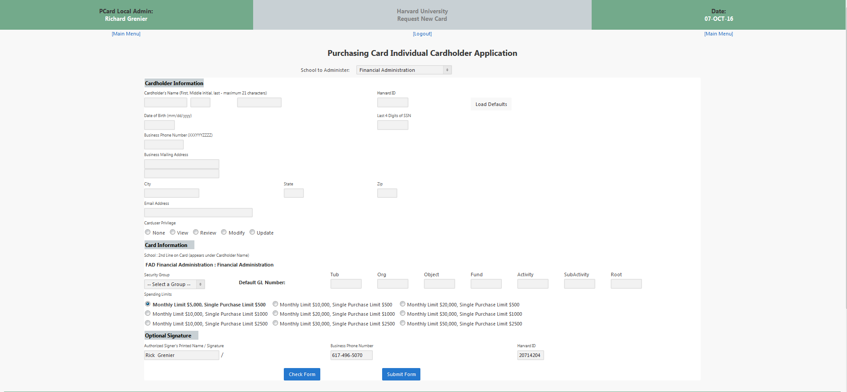
Changes:
- ‘School to Administer’ is built within the form and is now a drop down
- Slight change to the header information
- No repeat of menu functions at bottom of form
- ‘Spending Limit’ spacing condensed

Maintain Cards
Changes:
- ‘School to Administer’ is built within the form and is now a drop down
- Slight change to the header information
- No repeat of menu functions at bottom of form
- Ability to Sort
- Addition of ‘per page’ results (rather than long page)
Report on Purchasing Cards
Changes:
- ‘School to Administer’ is built within the form and is now a drop down
- Slight change to the header information
- No repeat of menu functions at bottom of form
Report on Card Usage
Changes:
- ‘School to Administer’ is built within the form and is now a drop down
- Slight change to the header information
- No repeat of menu functions at bottom of form
- Ability to Sort
- Addition of ‘per page’ results (rather than long page)
Detailed Transaction Report
New Look
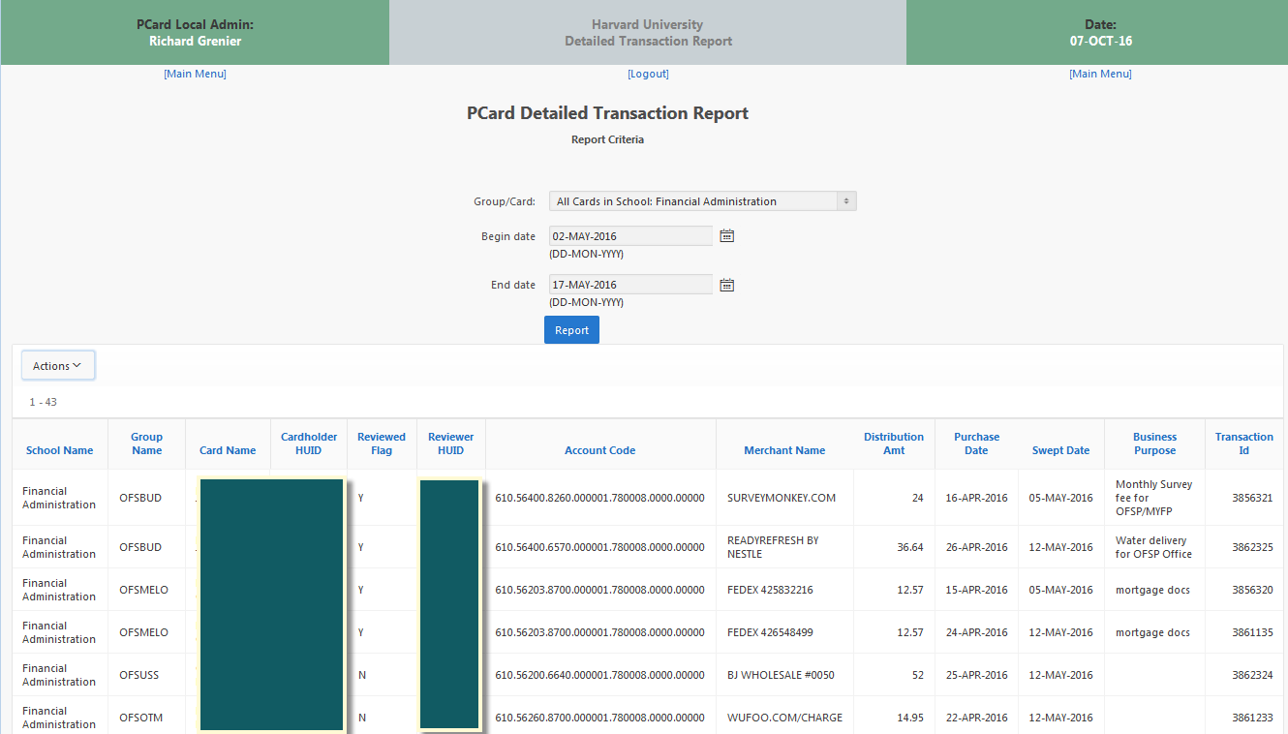
Changes:
- ‘School to Administer’ is built within the form and is now a drop down
- Calendar Date fields
- Slight change to the header information
- No repeat of menu functions at bottom of form
- Ability to Sort
- Addition of ‘per page’ results (rather than long page)
- Ability to Export via ‘Actions’

Add/Maintain Card Reviewers / Add Maintain Group Reviewers
New Look
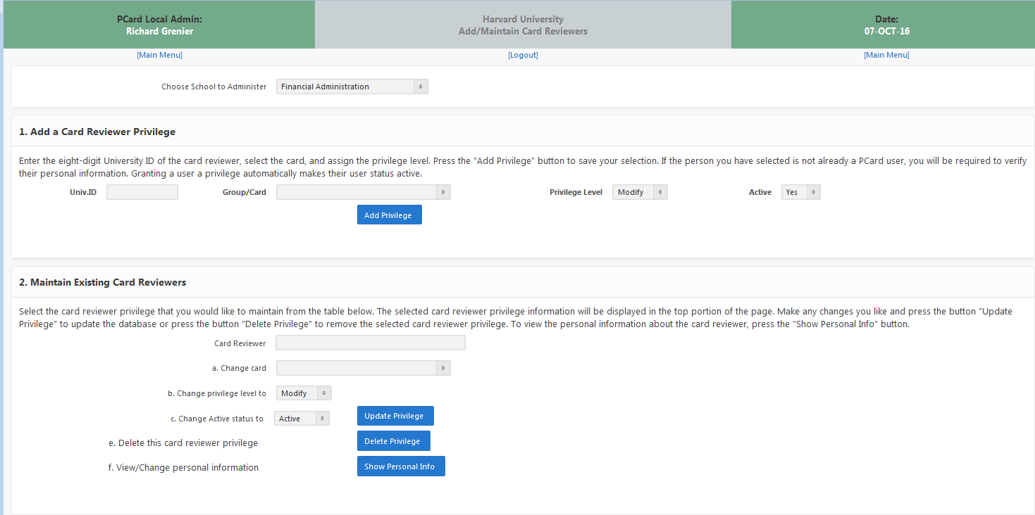

Changes:
- ‘School to Administer’ is built within the form and is now a drop down
- Slight change to the header information
- No repeat of menu functions at bottom of form
- Addition of ‘per page’ results (rather than long page)

Report on Group Reviewers
Changes:
- ‘School to Administer’ is built within the form and is now a drop down
- Slight change to the header information
- No repeat of menu functions at bottom of form
- Ability to Sort
- Addition of ‘per page’ results (rather than long page)

