WV Reimbursement Menu

Invoice Search - Current
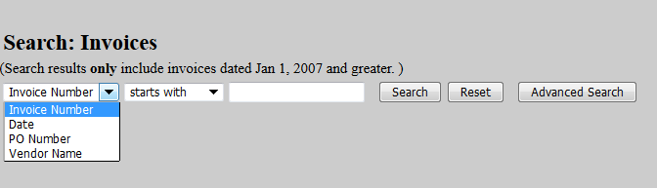

New Look
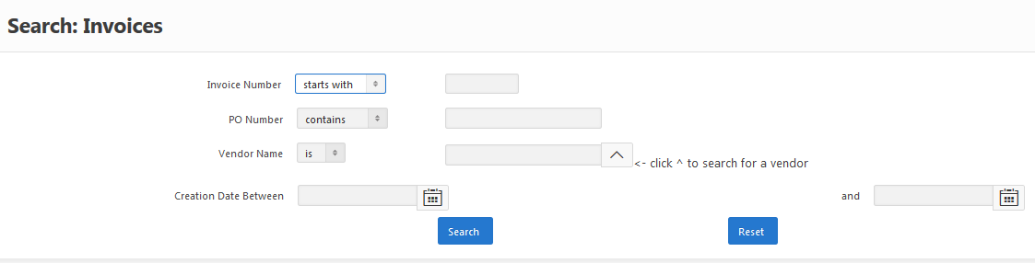

Changes:
- Addition of Creation Date Search using pop-up calendars
- Ability to Export information on the Results screen using the new ‘Actions’ button
- Printable screens when drilling down to additional data
- Ability to sort results at Header level

Open Requisitions - Current

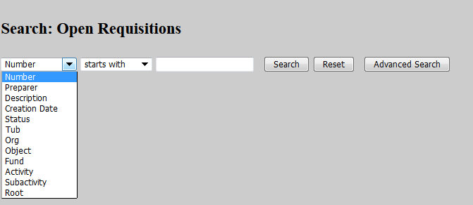

New Look
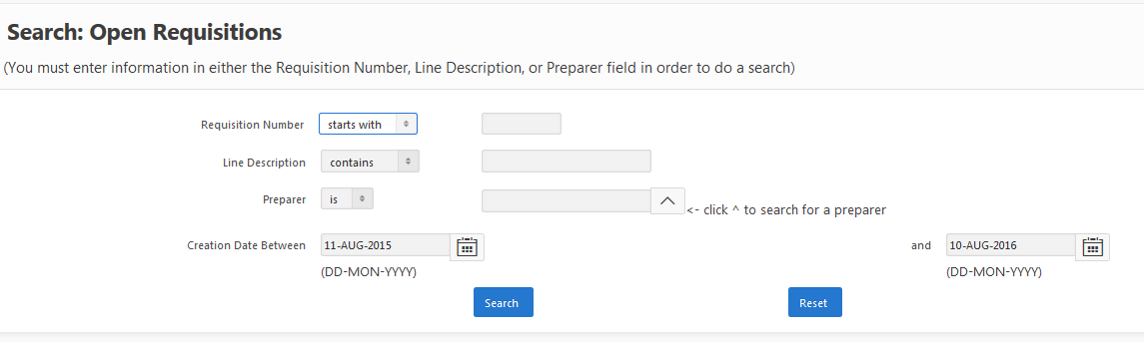

Changes:
- Addition of Creation Date Search using pop-up calendars
- Smart search of Preparer name
- Ability to Export information on the Results screen using the new ‘Actions’ button
- Ability to sort results at Header level

Requisition History – Current

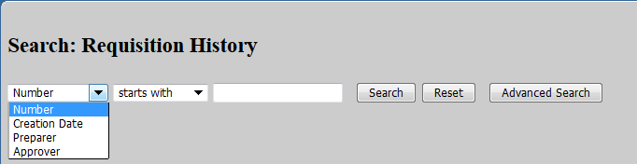

New Look
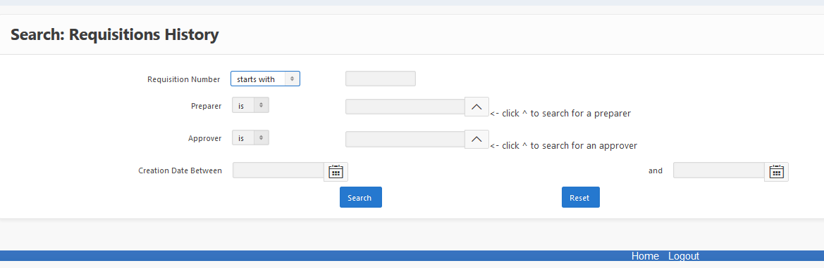

Changes:
- Creation Date Search using pop-up calendars
- Smart search of Preparer name
- Smart search of Approver Name
- Ability to Export information on the Results screen using the new ‘Actions’ button
- Printable screens when drilling down to additional data
- Ability to sort results at Header level

Reprint Web Reimbursement - Current

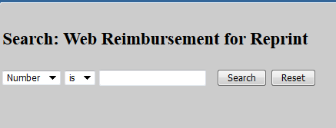

New Look

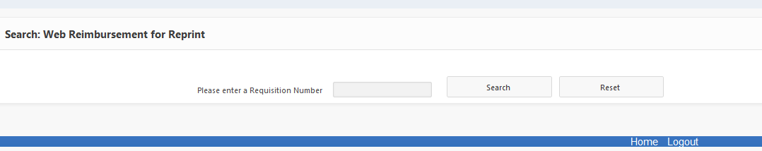

User Search – Current

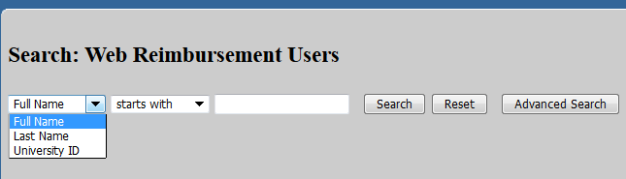

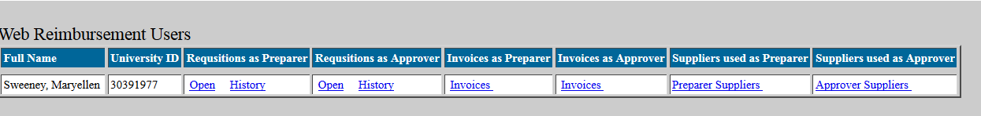

New Look

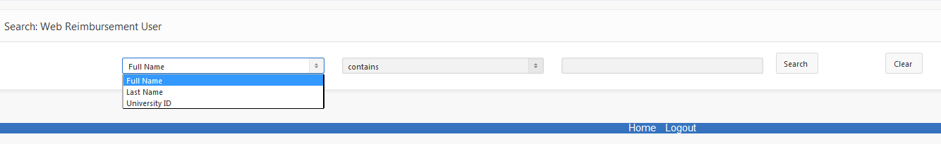

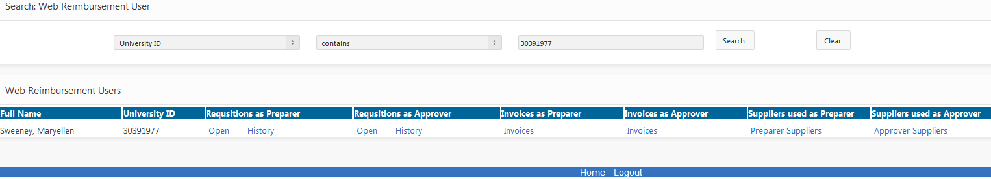

Changes

- Printable screens when drilling down to additional data

