How to View an Invoice in Oracle Multi-Currency (Oracle MC)

To view an invoice in the Oracle MC system, a user must go through the following steps.
- Navigate to the Oracle E-Business Suite home page located below and log in with Harvard Key
https://hgrsprod.huit.harvard.edu/ (Going live April 1, 2024)
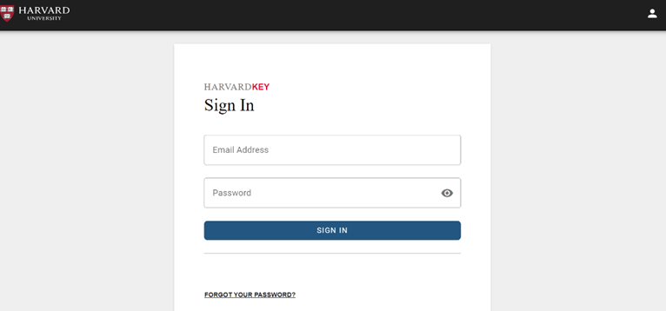

- On the Navigator, under the HGRS^AP^Inquiry responsibility dropdown click Invoices.
Note: The jnlp (Java Network Launch Protocol) will automatically download for the Oracle MC application.
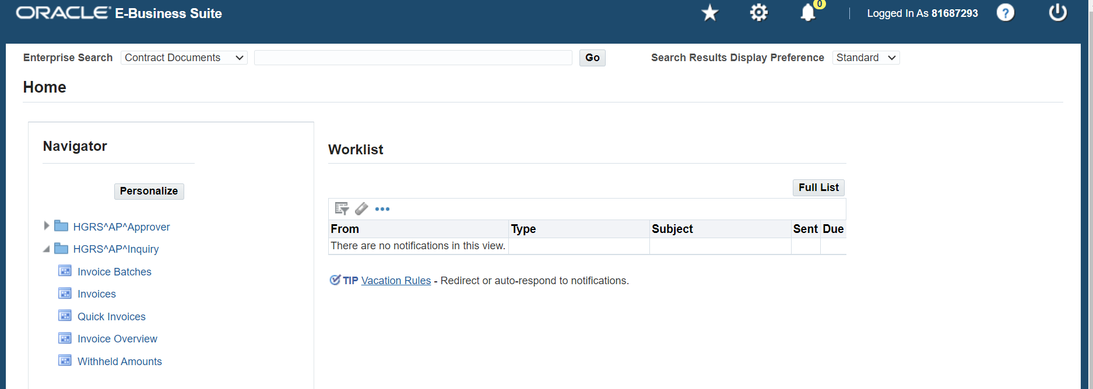

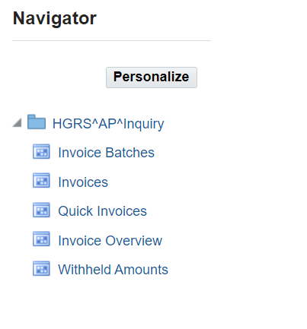

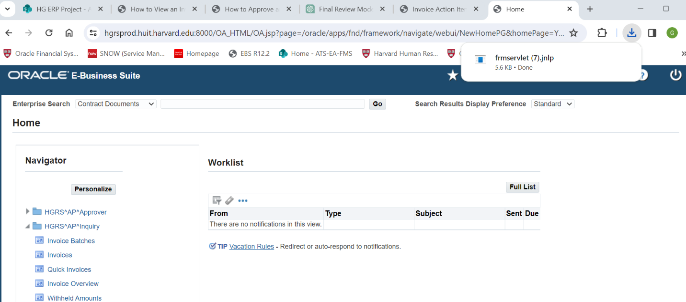
- Open the downloaded jnlp file to launch the Oracle application as shown above.

- On the Find Invoices screen, enter in the search parameters for the invoice.
Note that Oracle MC uses the term “Trading Partners” for HG vendors.
  - Click find after entering your specific search parameters.

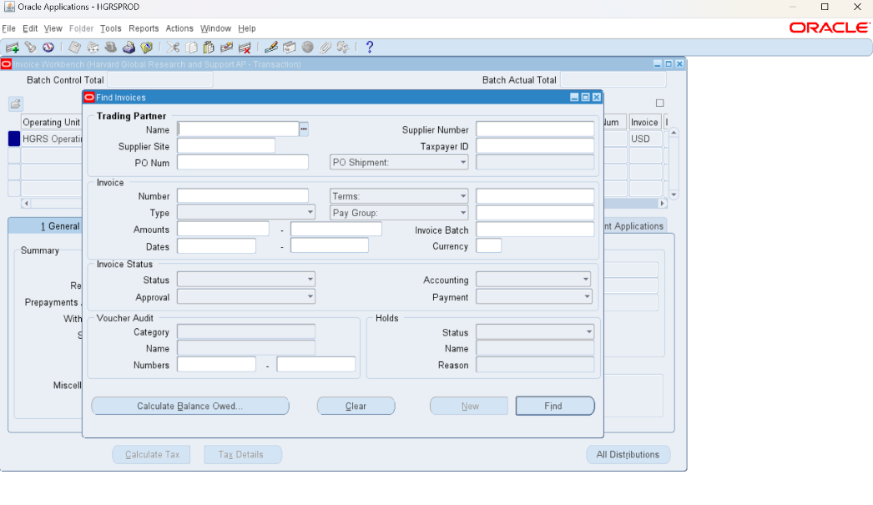
  - If the exact name is not known, try searching with partial words use the wildcard percentage sign (%) to stand for missing characters or words.
  - Clicking the ellipses at the end of the Name field opens the list of HG vendors (aka “Trading Partners”). Place the beginning letters of the vendor and a “%”.
The example below finds all the vendors whose name begins with “BO” (BO%)
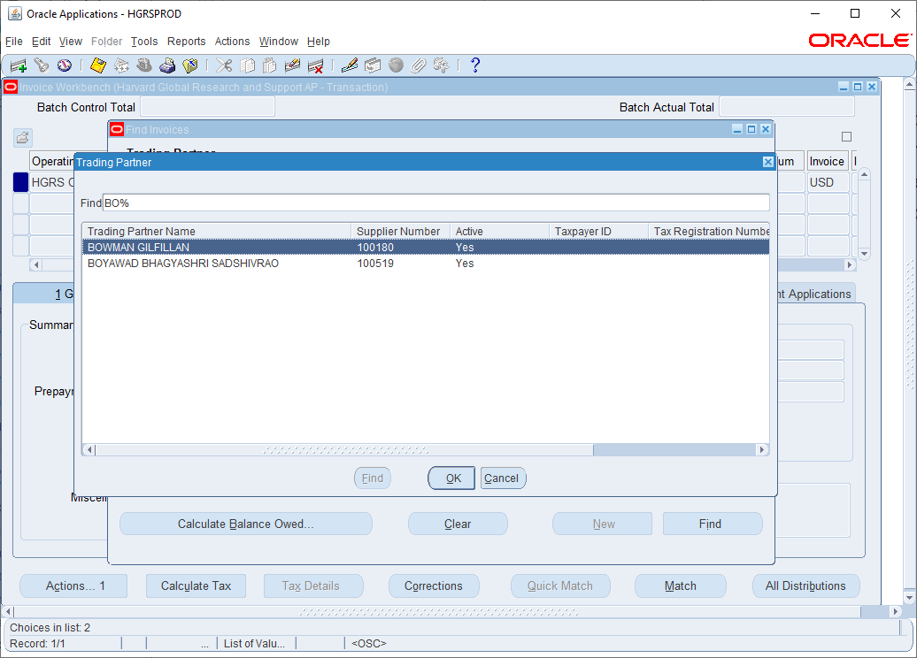
Once the vendor has been selected, the search can be narrowed by entering invoice status parameters. Often it helps to narrow down the search for paid, unpaid, or partially paid invoices by selecting the status on the payment field dropdown.
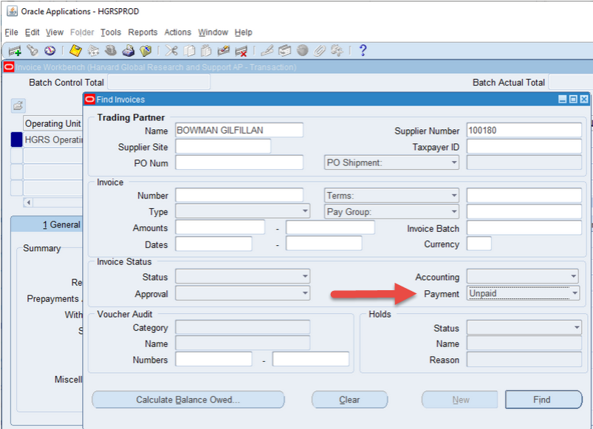

  - All invoices matching the parameters will be shown in the invoice workbench panel, as shown in the example below.
  - Navigate through the invoice workbench panel by using the arrow keys or the scroll bars.
  - The selected invoice is indicated by the square filled in a dark blue shading before the first field. The Invoice Trading Partner and Invoice Number will always be a unique combination.

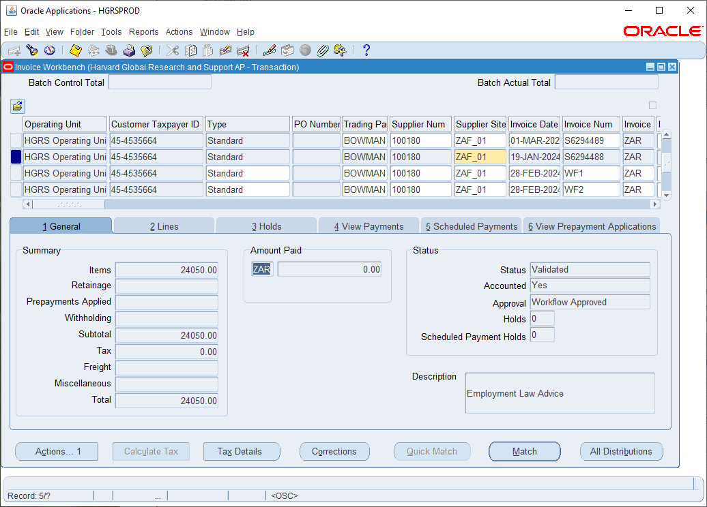
View the Invoice Lines – click the “2 Lines” tab
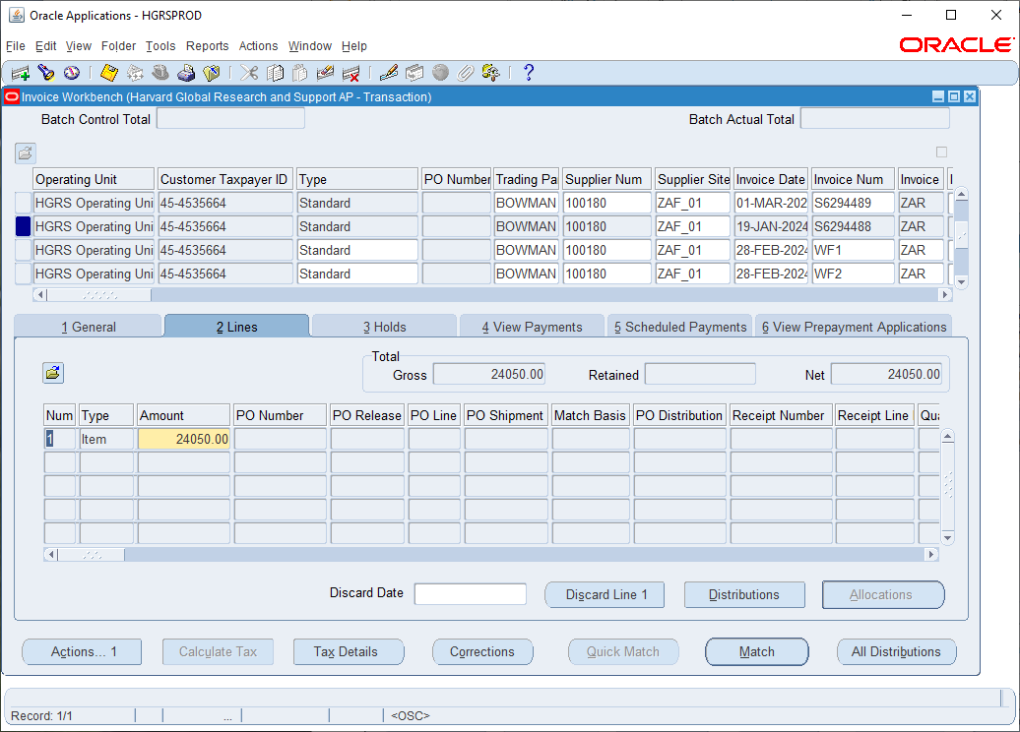
View the Account Distributions – click the “Distributions” button.
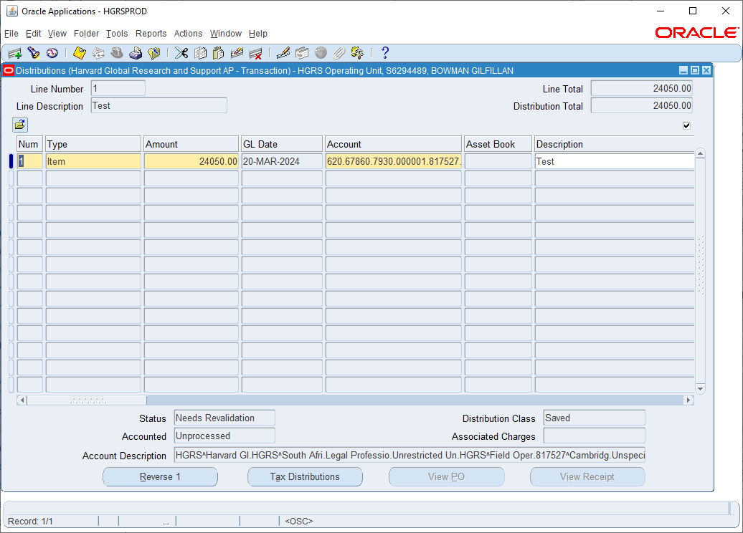
View the Attached Documents – click the paperclip on the toolbar
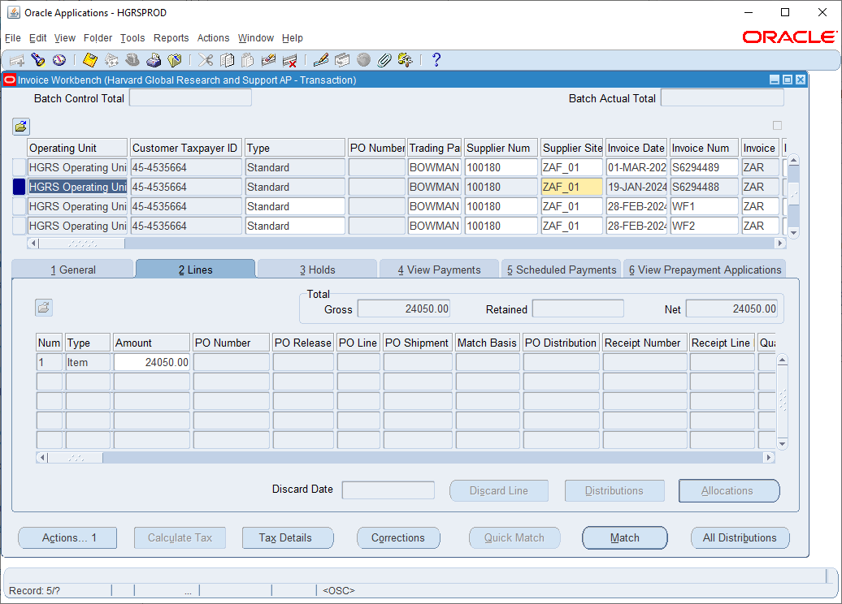
Click Open Document…
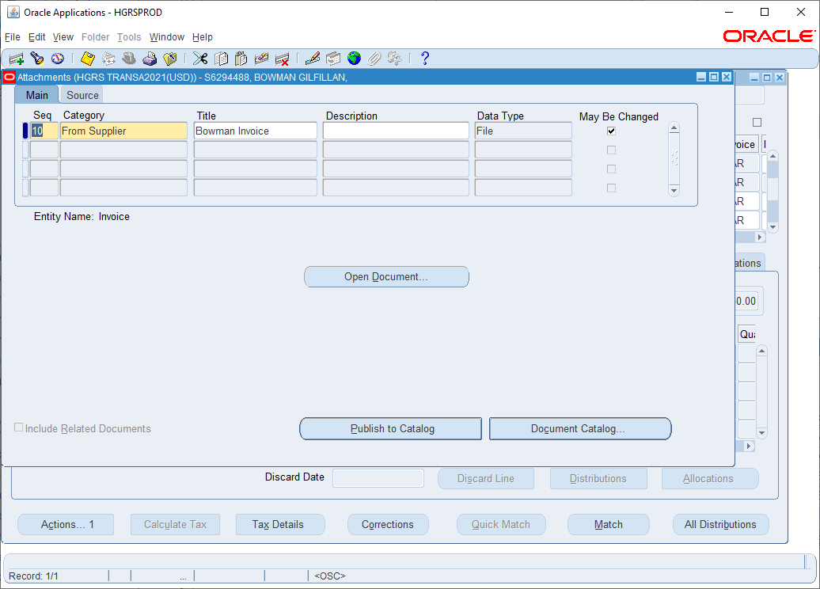
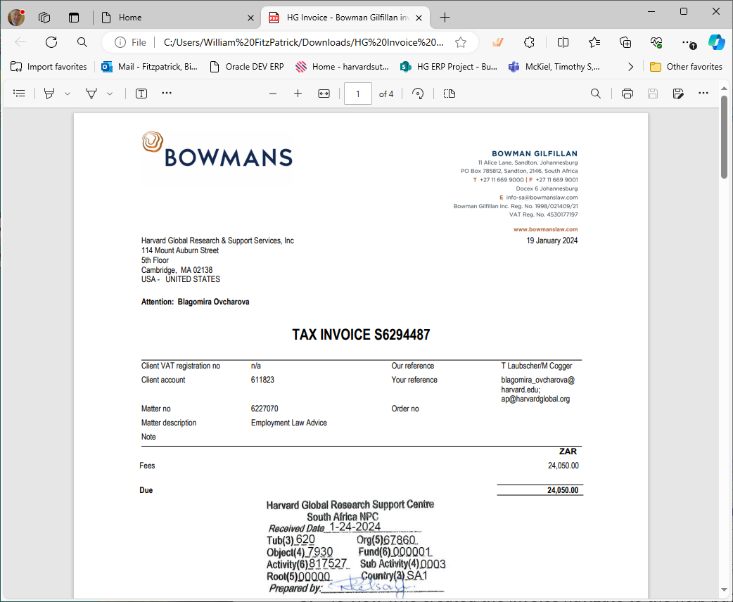

To view who created the invoice navigate to the help button and click “Record History”. The eight digit Harvard University ID (HUID) of the user who entered the invoice will be shown, as well as the date it was created, who last updated it, and the date it was last updated.
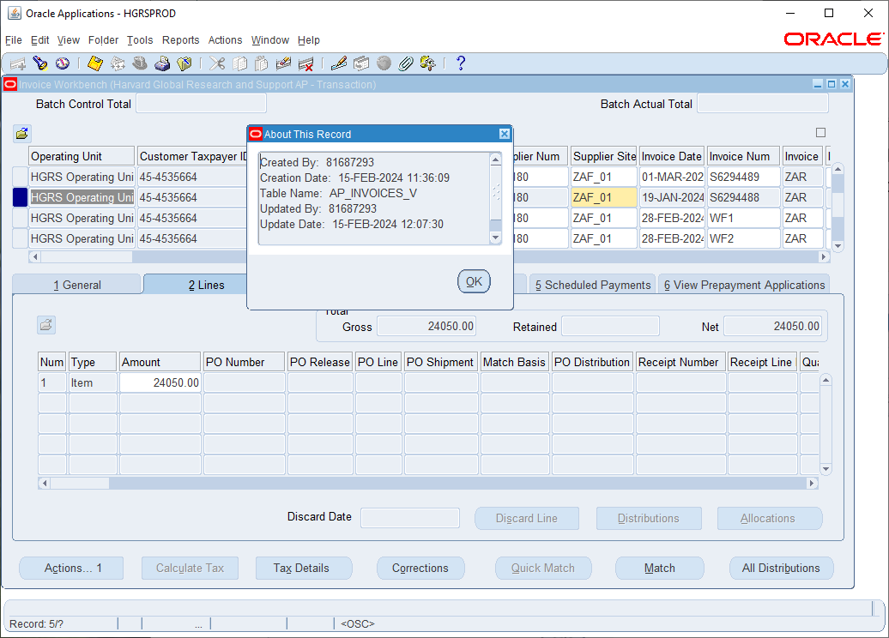

Questions & Contacts
- For invoice-related inquiries, contact HG Finance Team, info@harvardglobal.org
- For Oracle MC system inquiries, contact Ghiscard Pierre, ghiscard_pierre@harvard.edu

