How to Approve an Invoice in Oracle Multi-Currency (Oracle MC)
INTRODUCTION
To create invoice accounting, the invoice entered will have to go through the Oracle MC AP (Accounts Payables) Approval workflow process. This means an invoice will need to gain approval from various approvers designated by level per Tub & Org based on the amount of the invoice. Below is a visual detailing the various levels of approvers and the corresponding invoice amounts that necessitate their approval. After an invoice has been approved, it will go to the final reviewer (a member of the Harvard Global Finance staff) for approval.
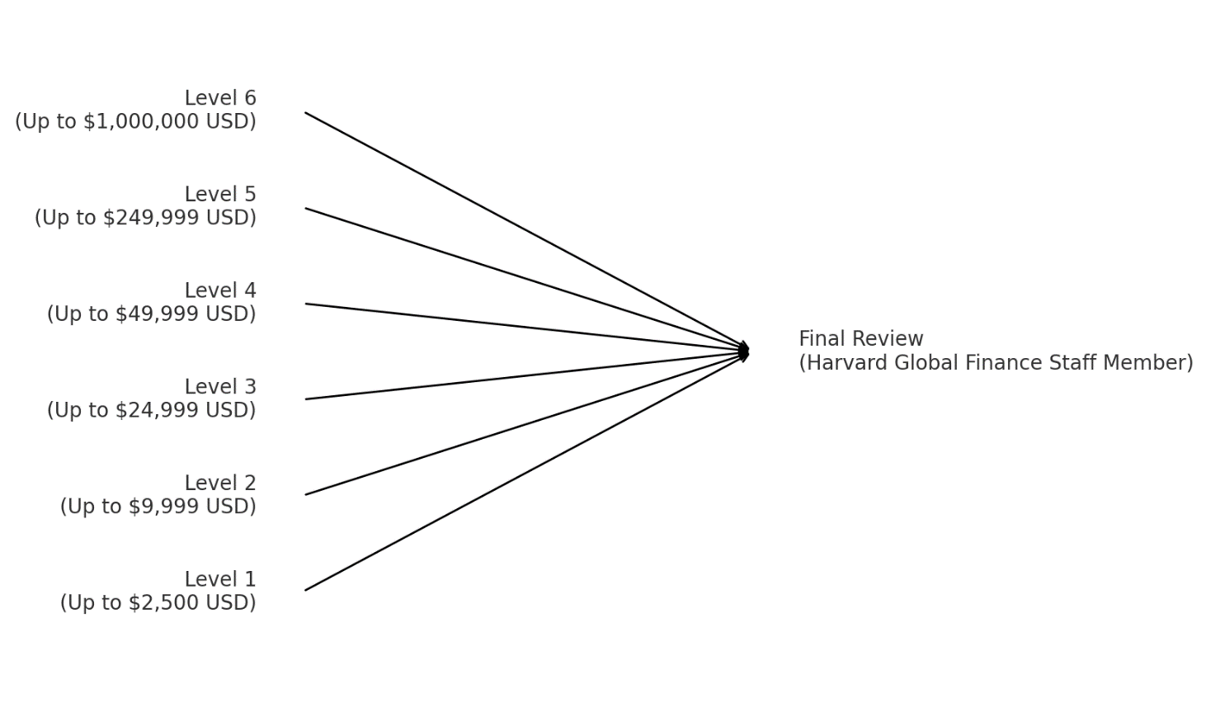

The approver will receive an email notification of the invoice needing their approval. The invoice needing approval will be attached to the email, and the body will have information around approval/action history and a description and line summary of the invoice.

PROCESS STEPS
The following steps will be taken to approve or reject an invoice.
The user will receive an email notification from “Workflow Mailer”
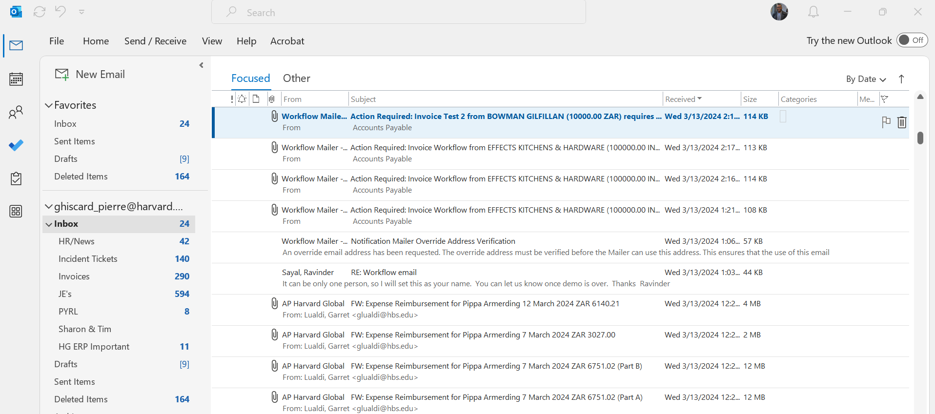
The example below shows the content of the email.
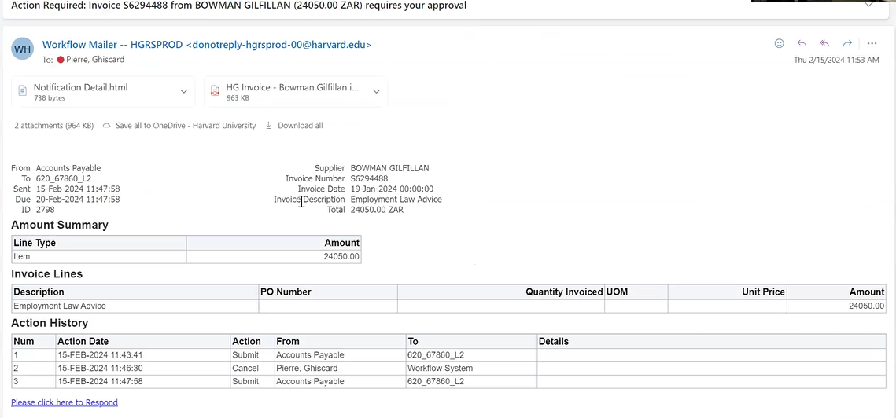
- Once a user clicks on the URL at the bottom of the email labeled “Please click here to respond” they will be taken to a HarvardKey login for Oracle E-Business Suite.
  - Alternatively, a user can approve their invoices by logging into Oracle MC directly
(see URL below) and viewing their worklist on the Oracle E-Business home page.
The worklist will display all the unapproved invoices that require their review and approval.
https://hgrsprod.huit.harvard.edu (Going live April 1, 2024)
Below is the screen shot showing the login through Harvard Key.
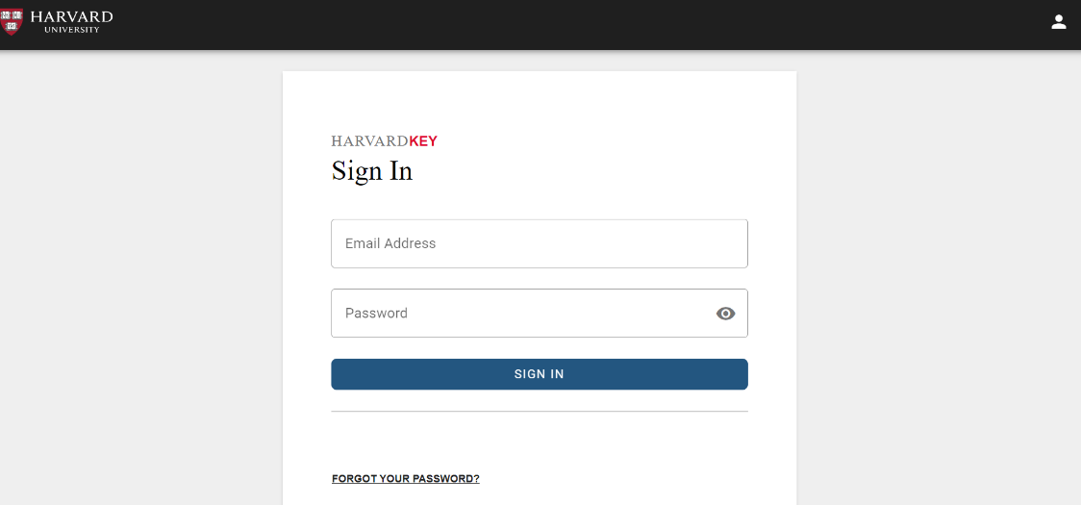
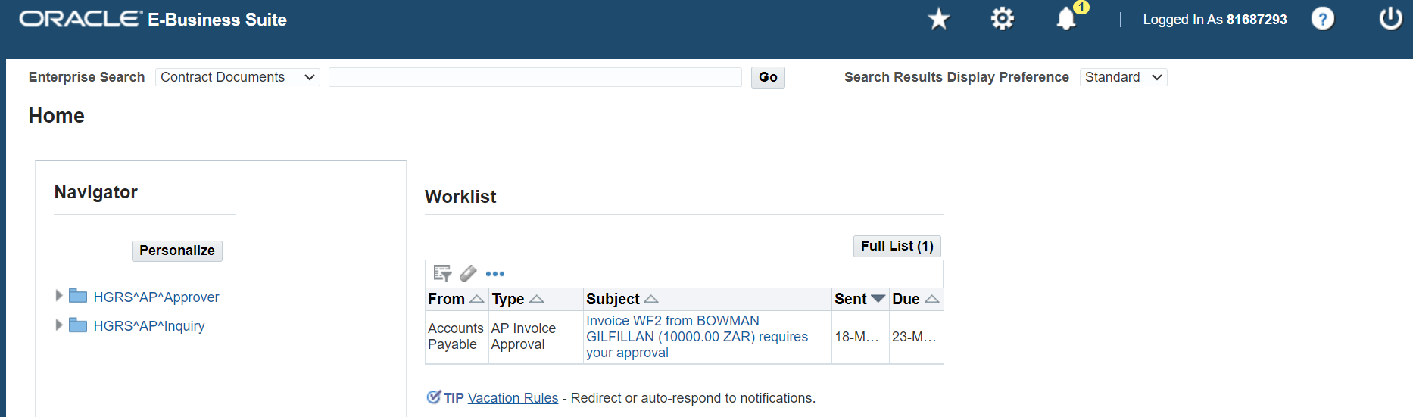

- They will then be redirected to an Oracle E-Business Suite web page where they will have access to information about the invoice, including the GL code associated with the invoice and the invoice attachment. This page will also have all the approval actions that have been taken on the invoice. The invoice will be approved or rejected on this page.
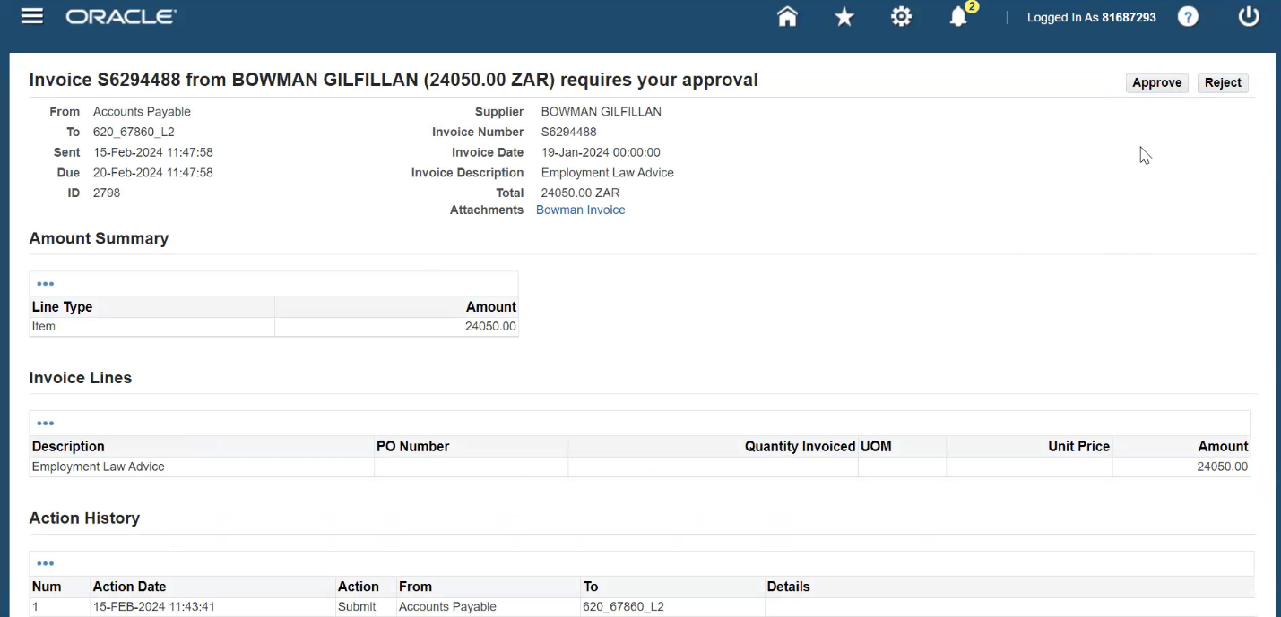

- To view the invoice attachment, click the attachment link under the invoice total.
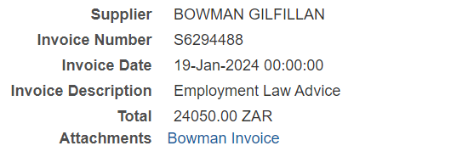
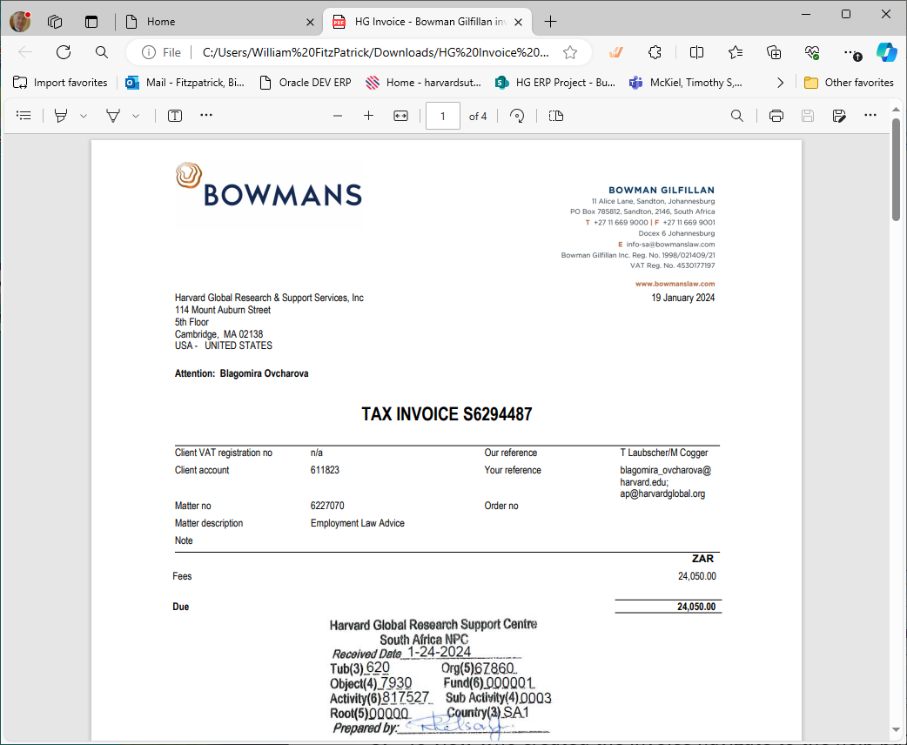

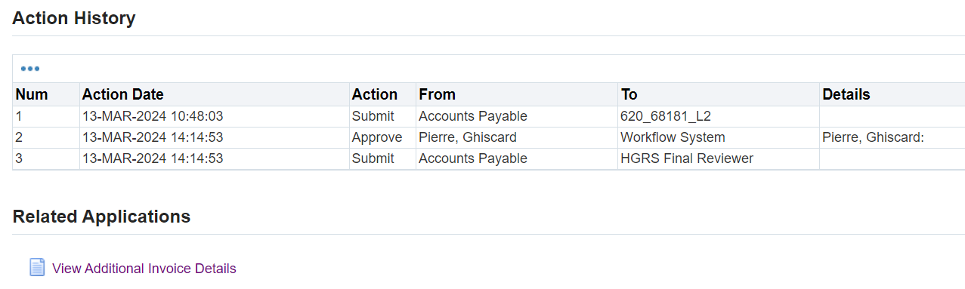
- Scroll past action history and Click “View Additional Invoice Details” to view GL coding for the invoice and add a note.
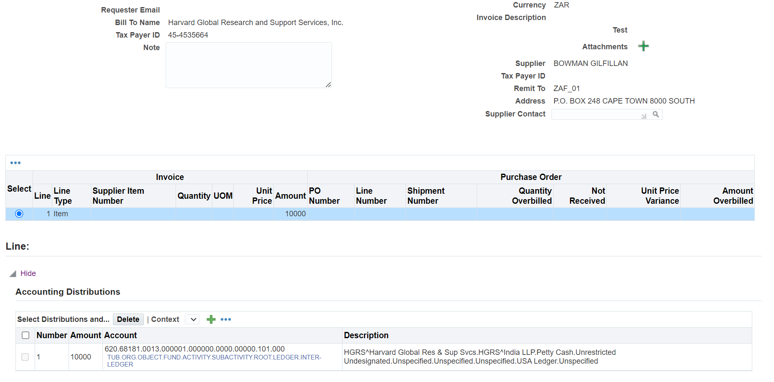
- To edit the coding string, click the magnifying glass next to the account field.
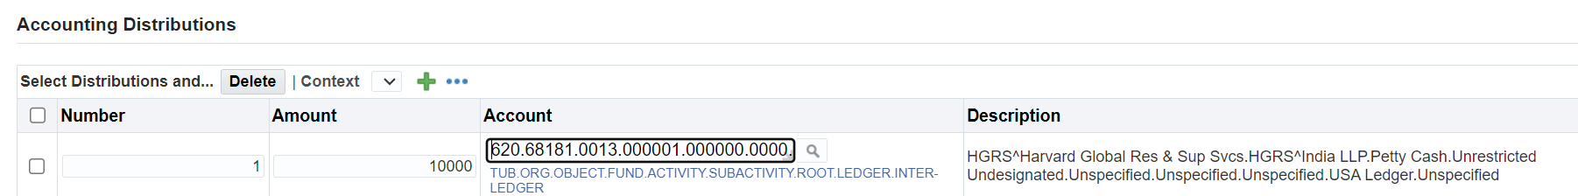
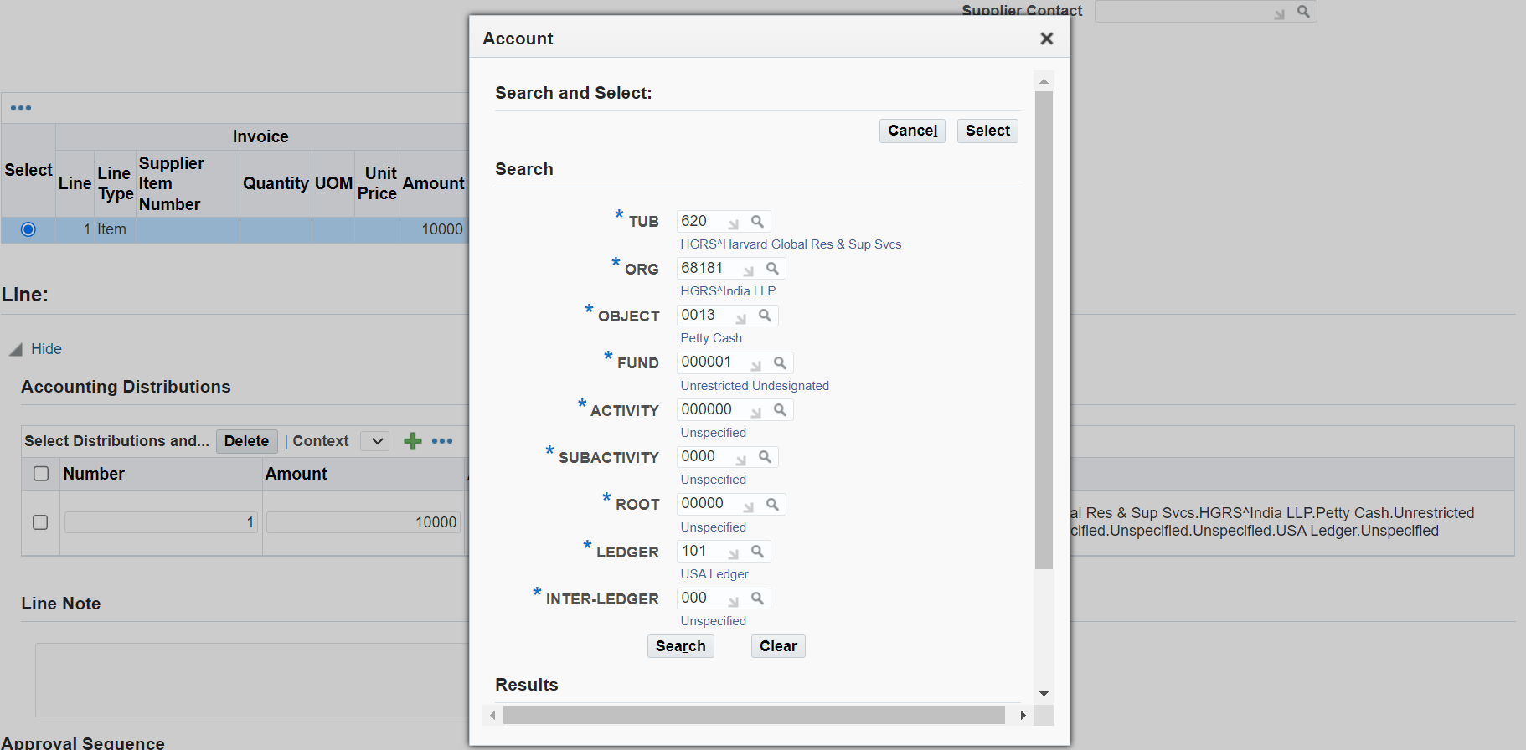

- Change the coding string and click search. Ensure the coding string has changed in the code combination field and click quick select next to the updated code combination. If the coding string has not been entered before, you will need to click “Create” before clicking “Quick Select”.

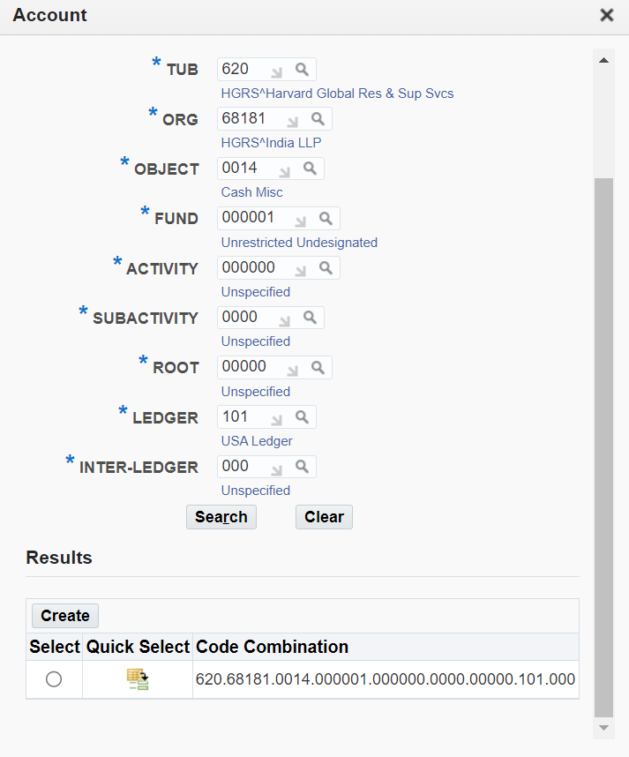

- Scroll to the top or bottom of the page to approve the invoice.
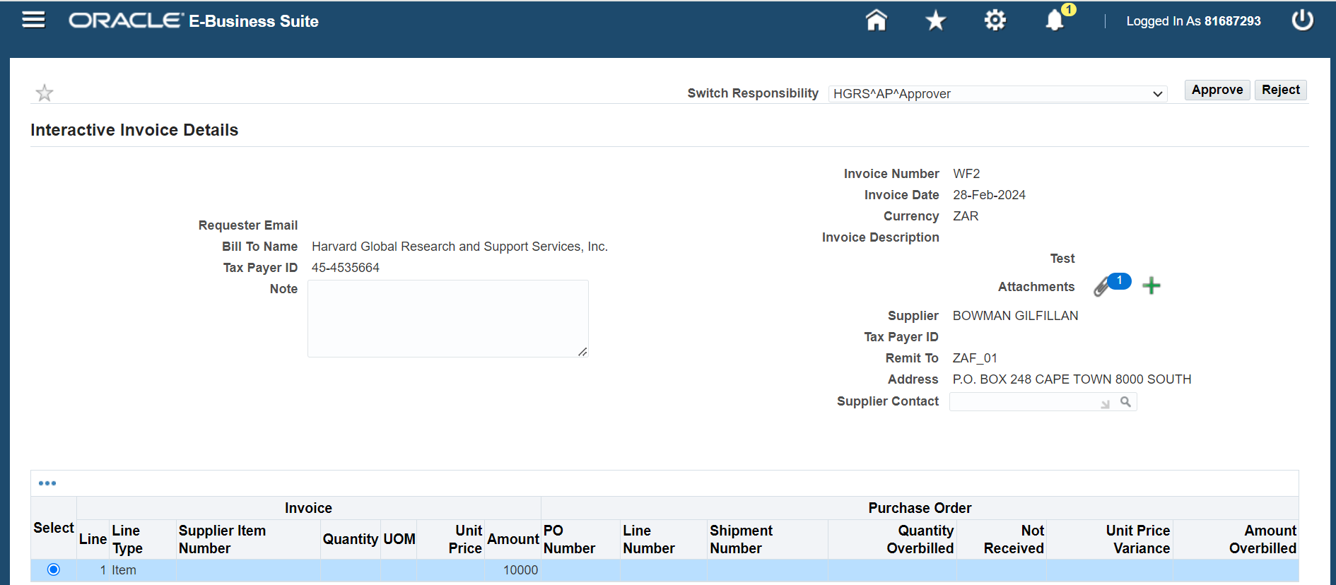

- Once the invoice has been reviewed and the Account updated, if needed, the user can either approve or reject it.
  - If the approver clicks “Approve” the invoice will be sent to an HG Staff member for Final Review. Once it has passed the final review, it will then be posted to the Oracle MC GL and be ready for payment.
  - If the approver clicks “Reject” the invoice will need to be reviewed and resubmitted through the approval process.

Questions & Contacts
- For invoice-related inquiries, contact Harvard Global Finance Team, info@harvardglobal.org
- For Oracle MC system inquiries, contact Ghiscard Pierre, ghiscard_pierre@harvard.edu

