GL-PCR Funding Change Reclassification

Purpose
Use this procedure to move transactions to a different fund value on payroll entries when there is a known amount to move. The simple funding reclassification is completed by adding the proper tubs, orgs, and periods within a fund to reclass with a HUID.

Trigger
- A specific amount of an employee’s salary need to be moved to a different fund
- A specific amount plus the fringe amount of an employee’s salary and fringe need to be moved to a different fund

Prerequisite
- Preparer MUST have access to GL-PCR salaries in order to use the Funding Change Reclassification

Procedure
- First open Oracle, then select your General Ledger responsibility HRVD^GL^... > Journals >HUGL Adjustment
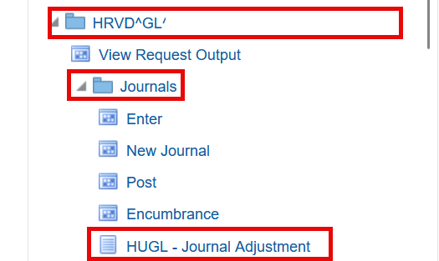

- Once the HUGL Journal Adjustment page appears select the Funding Change Reclassification tab
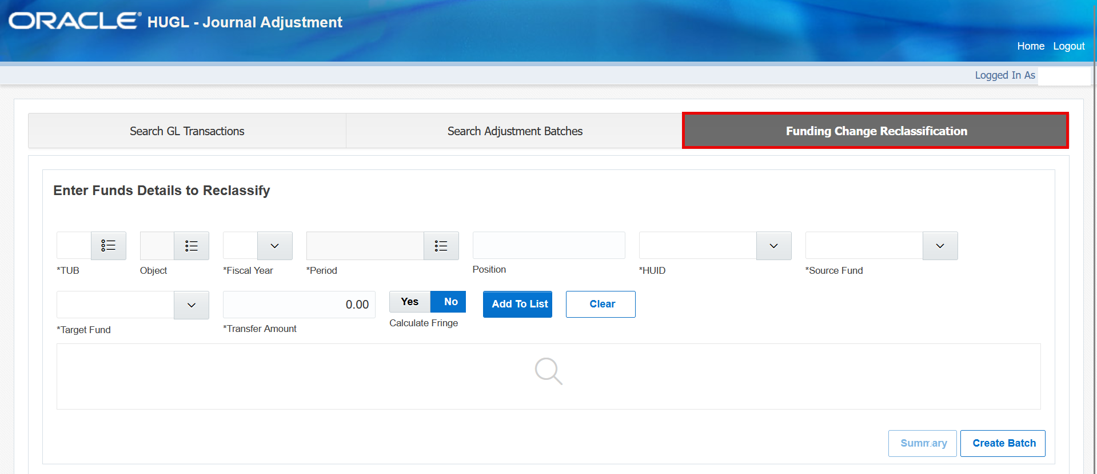
- When using the tool, the mandatory fields that must be filled out include:
- Tub
  - Multiple tubs can be chosen
- Fiscal Year
- Period
  - Multiple periods can be chosen
- HUID
  - Multiple users can be added to the list by querying one at a time

- Once the mandatory fields have been filled out, select Add To List

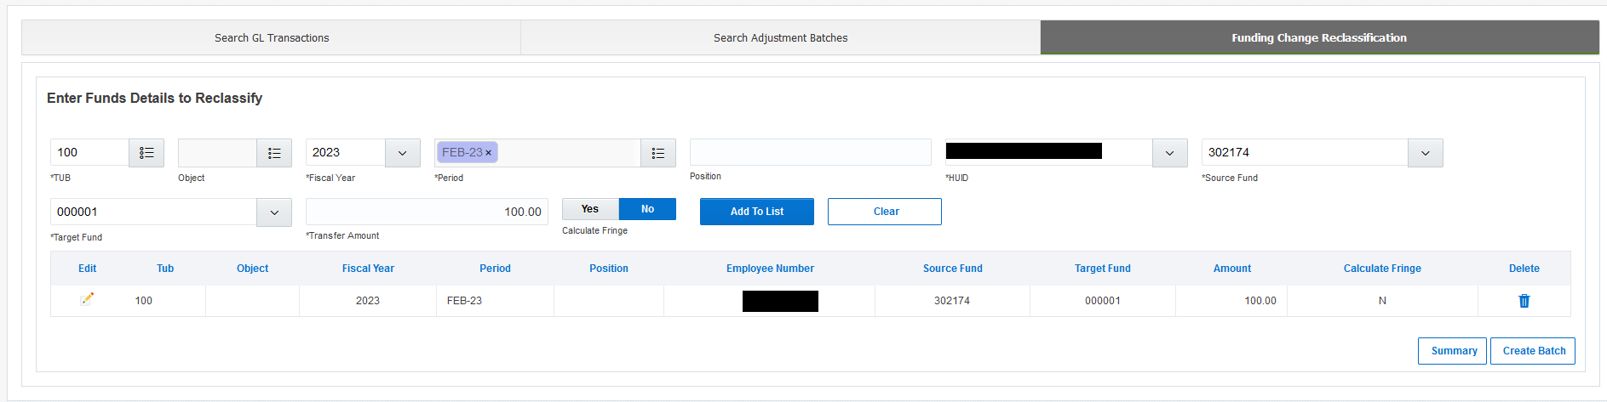

- The Source Fund is where the funds are originally located, and the Target Fund is where the new transfer amount will be relocated
- The default of Calculate Fringe is No
- Add additional employees by filling out the data points again and “Add to List” until complete
  - Note: 10 lines is the highly recommended maximum lines that should be added

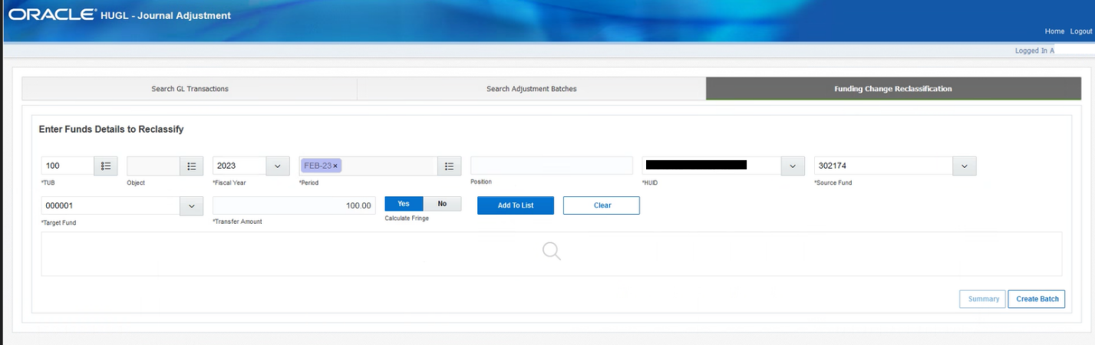

- To add fringe, select Yes for Calculate Fringe

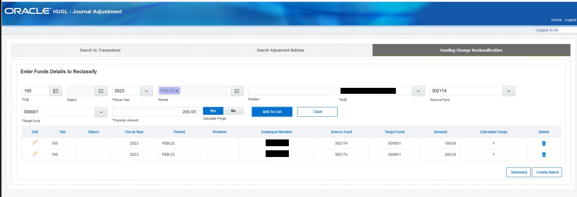
- Resulting screen if Calculate Fringe = Yes, note the Calculate Fringe column value = Y

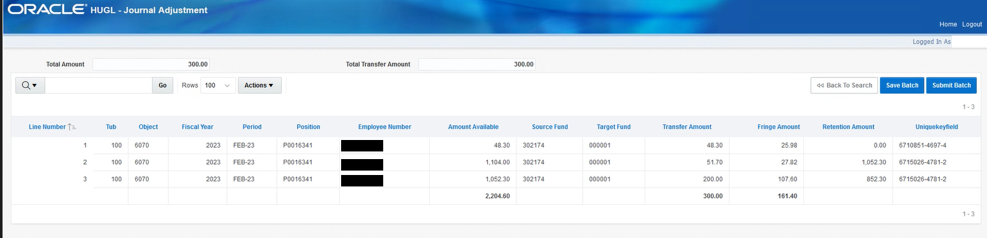
- The Fringe Amount column will show the calculated fringe if Calculate Fringe is Yes.

- If there are edits to be made in any line, select the pencil icon under in the Edit column.
To remove a line, select the trash icon in the Delete column.

- Once the lines have been entered, if desired, select Summary to view debit/credit amounts by fund value.

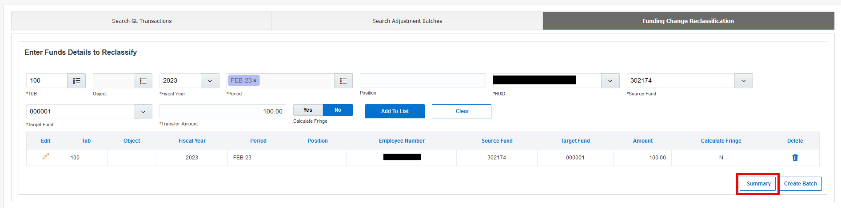

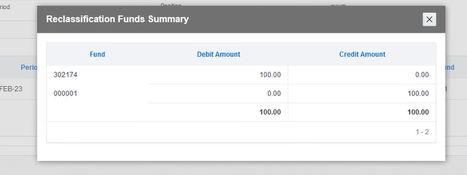

- When the batch is as desired, select Create Batch. The system will then create the GL-PCR batch. Note, there may be a slight delay while this occurs since checks are being performed.

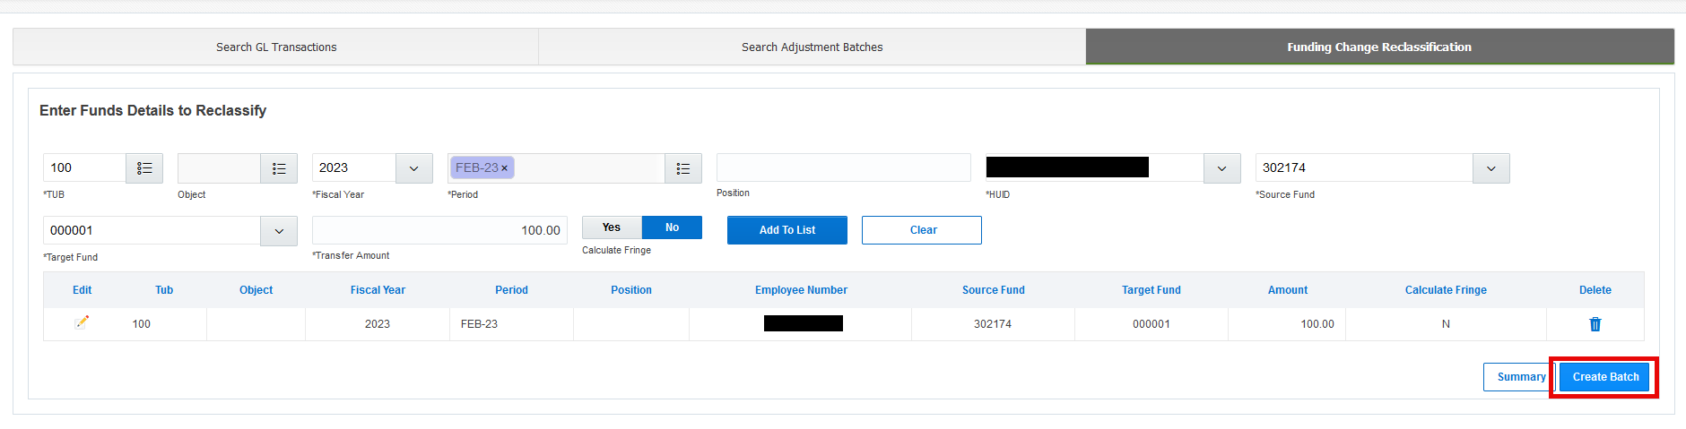

- When completing a Transfer Amount in Funding Change Reclassification, if the entered amount exceeds the fund amount available, a notification will appear.

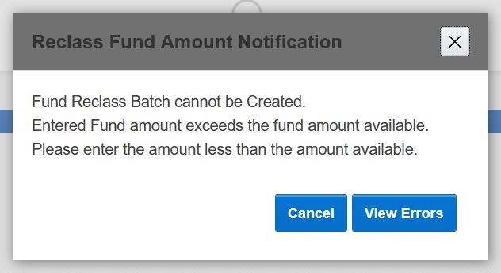
  - Clicking on View Errors pops up another screen with the detail of the error.

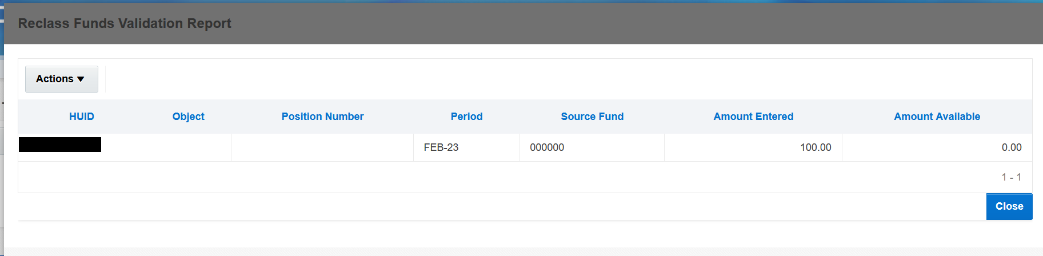
- Review the Amount Entered and the Amount Available then click close
- Note, if no transfer amount was entered the Reclass Funds Validation Report will be blank.
- Make the proper edits on the selection screen then click Create Batch again.

- If there are no errors found, a new screen with the transfer amounts will appear for review

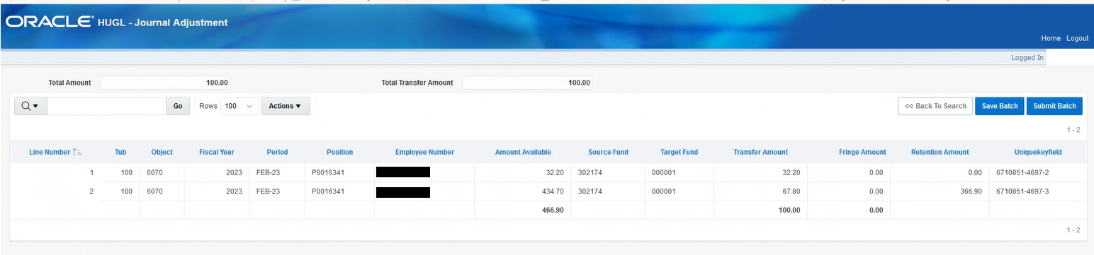
- Users should review all data on the screen, especially Transfer and Fringe Amounts.

- At this point, users can either Save Batch or Submit Batch.
Selecting Save Batch allows other users to review the current batch before submission.

For either choice, two pop-ups will appear:
- One asking are you sure, click Yes if ready, no to return to the selection screen.
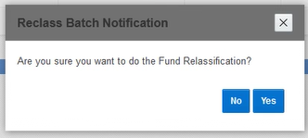
- Two, asking to select the GL Effective Date, which must be in an open accounting period, then select Proceed

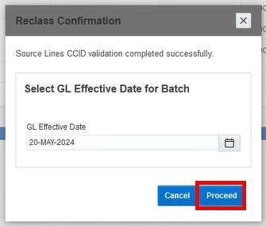

- For Save Batch, continue to STEP 11
- For Submit Batch, go to STEP 15

- Save Batch creates the batch in GL-PCR

- The system then notifies the user if the save was successful, Click Ok
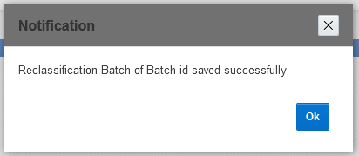

- The GL-PCR “Harvard – GL Adjustment” page will appear once the batch has been created

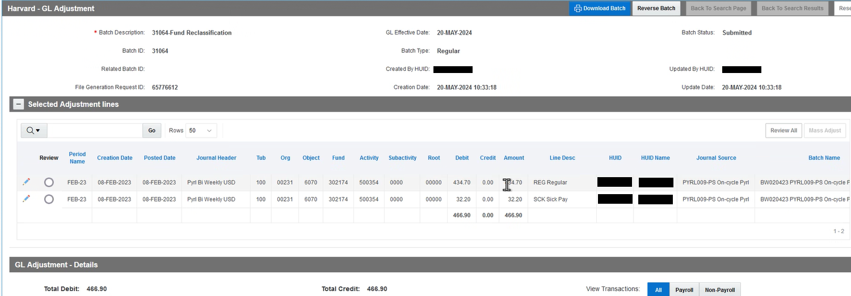

- Notate the Batch ID number (in the upper left hand side) for the reviewer.
The preparer of the adjustment should manually notify the reviewer at this point.
The reviewer would continue with the next steps to submit the batch.

- When the reviewer clicks Submit Batch a decision pop-up appears, if ready click Proceed.
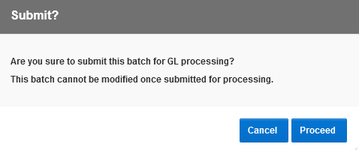
- Submit Batch sends the journal to the General Ledger for processing.
The system then notifies the user about the Concurrent Request submitted, Click Ok

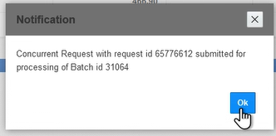

- The GL Adjustment page should appear with the batch status as Submitted.

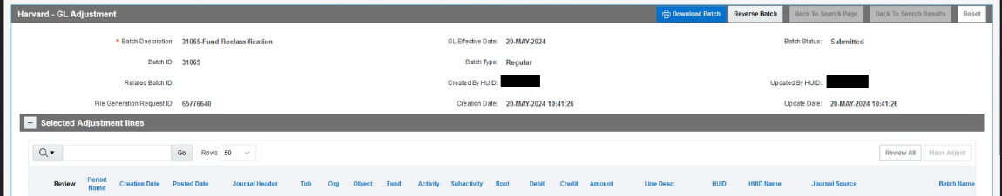

Questions?
If you have any questions, please contact the HUIT Support Center at 617-495-7777, or via email at ithelp@harvard.edu.

