Google Chrome - Authentication Failed
Error message when attempting to view a PDF in Oracle Financials

In Google Chrome the Adobe Acrobat extension can cause PDF documents which a user is trying to open in Oracle to error with “Authentication failed.”
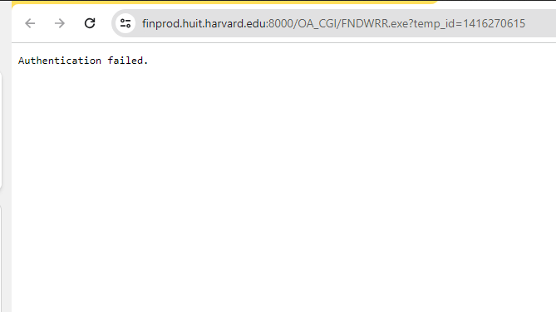
To fix this, launch Google Chrome.
On the toolbar, click on the Chrome menu > select Extensions > Manage Extensions:
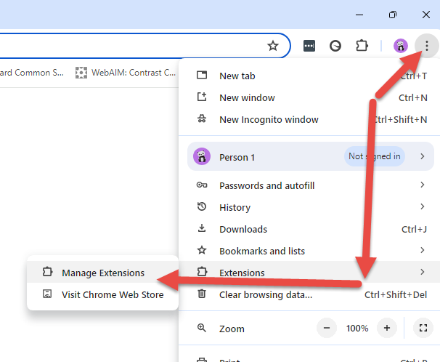
Toggle off the extension for Adobe Acrobat: PDF
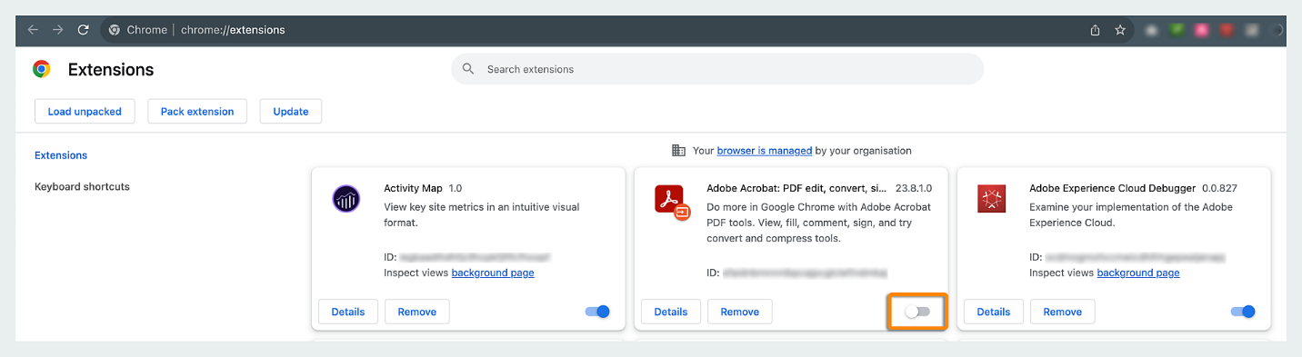
The pdf should now be able to be opened in Oracle Financials.

