Steps to resolve the error: “Missing Security Attributes” or “Bad Request”:
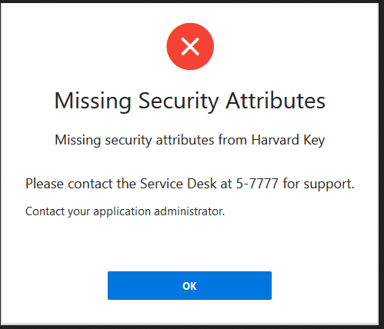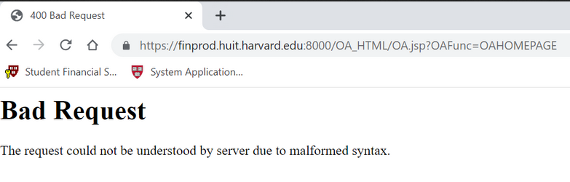
- Close Excel and all web browsers
- Go to your Windows Control Panel > Internet Options > General Tab > Delete >
Check all boxes, then hit Delete, Apply, OK
- Also in the Windows Control Panel > Java > Temporary Internet Files > Settings > Delete Files > Ok
- Open the Web Browser you like to use (Chrome, Edge or Firefox ESR) > Delete Cookies and Cache (Ctrl-Shift-Del, must choose “Everything”/“All Time” range)
- Close the Web Browser
- Open Web Browser and click the link for Oracle at https://huit.harvard.edu/finance
- Follow the Oracle instructions to log in

