The preference to require receiving has been removed on both the iProcurement preferences window AND during the requisition checkout process.
iProcurement Preferences
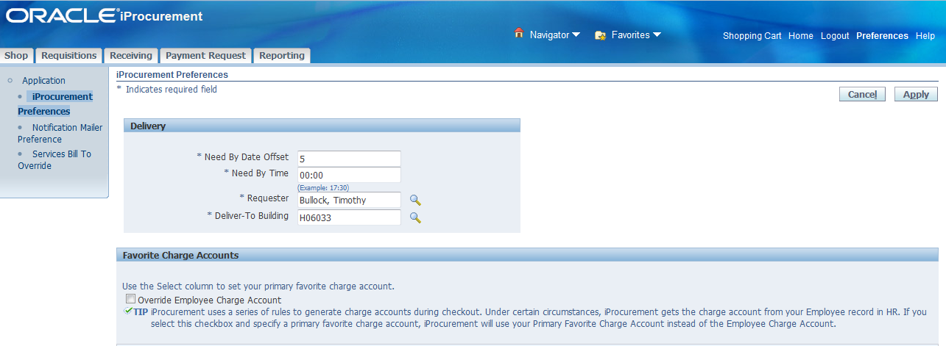
Requisition Information
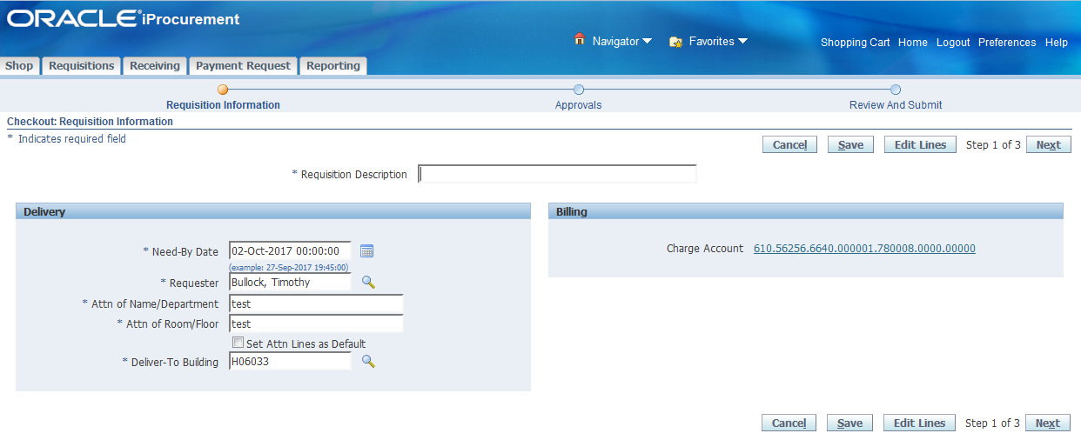
New iProcurement Features
New Views:
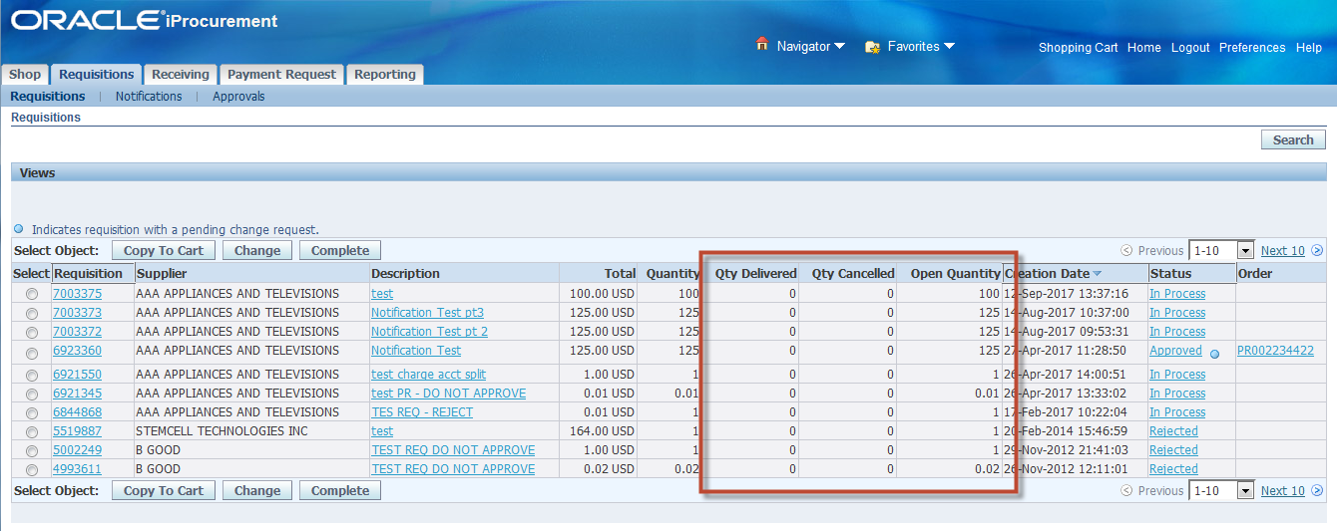
New columns have been added on the requisitions, requisitions search, and approvals sub tabs.
*Note: Qty Delivered = Qty Received
New fields also appear on requisition summary view:
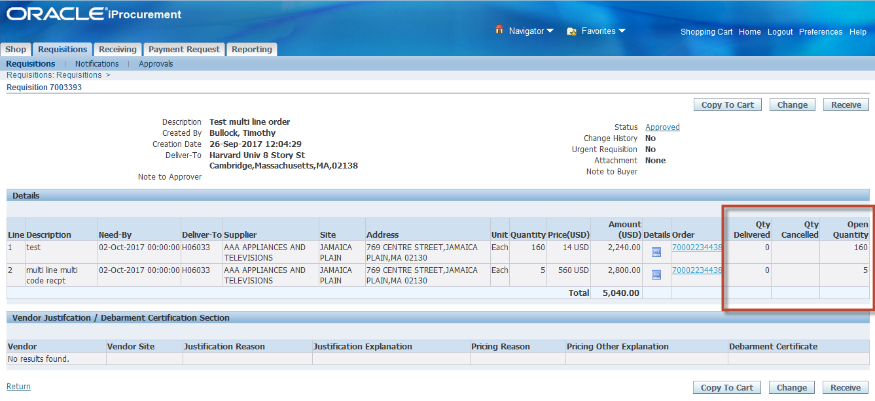

Receipt attachment feature:
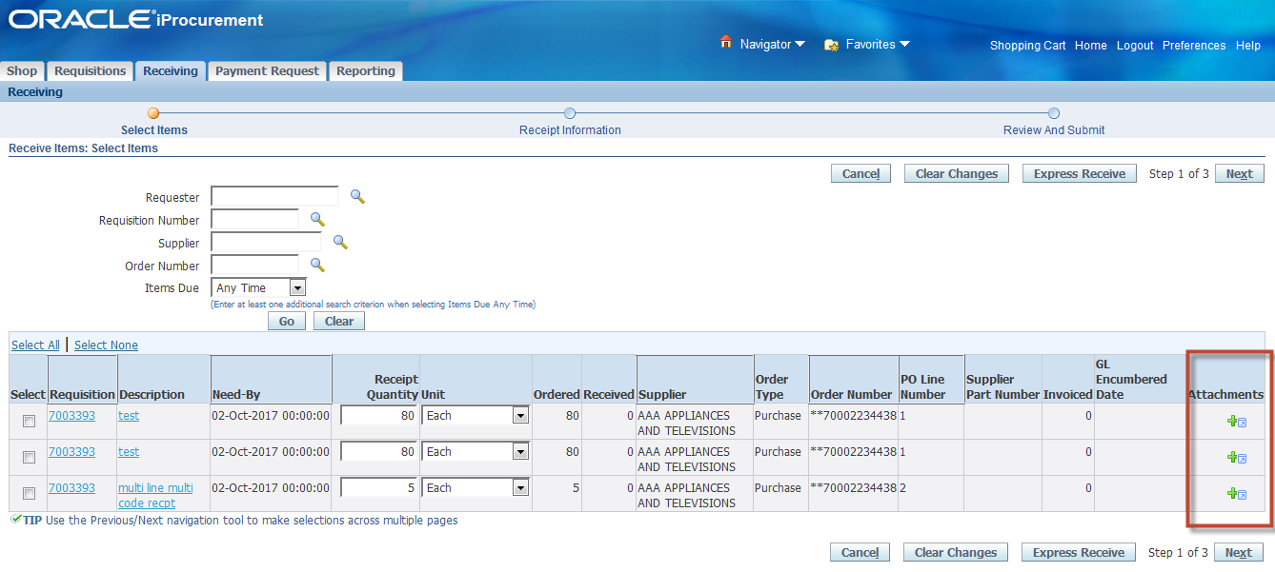
Attachments function appears on all receiving actions (Receive, correct receipt, return items)
^Note: These attachments are only attached to the receipt and cannot be seen under the requisition attachments.

