HCOM Receiving Threshold Change:
The preference to require receiving has been removed on both the iProcurement preferences window AND during the requisition checkout process.
iProcurement Preferences
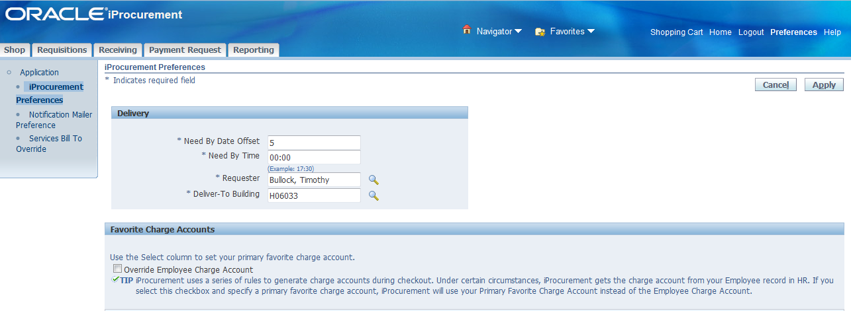
Requisition Information
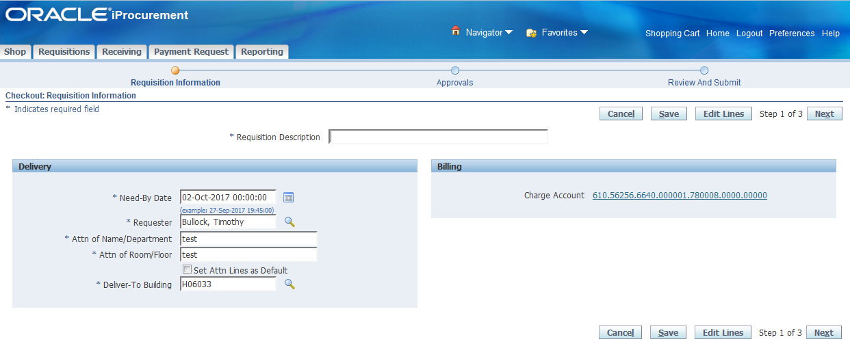

New iProcurement Features
New Views:
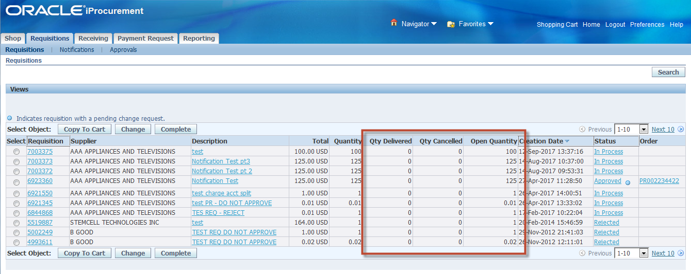
New columns have been added on the requisitions, requisitions search, and approvals sub tabs.
*Note: Qty Delivered = Qty Received
New fields also appear on requisition summary view:
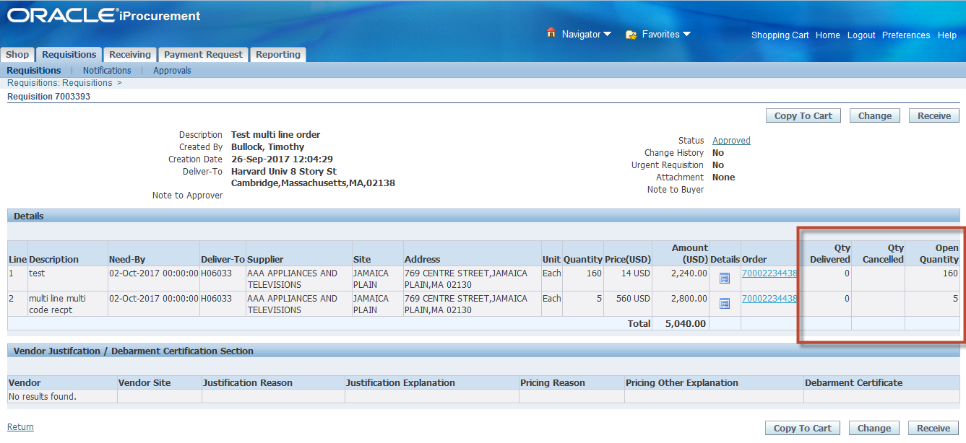

Receipt attachment feature:
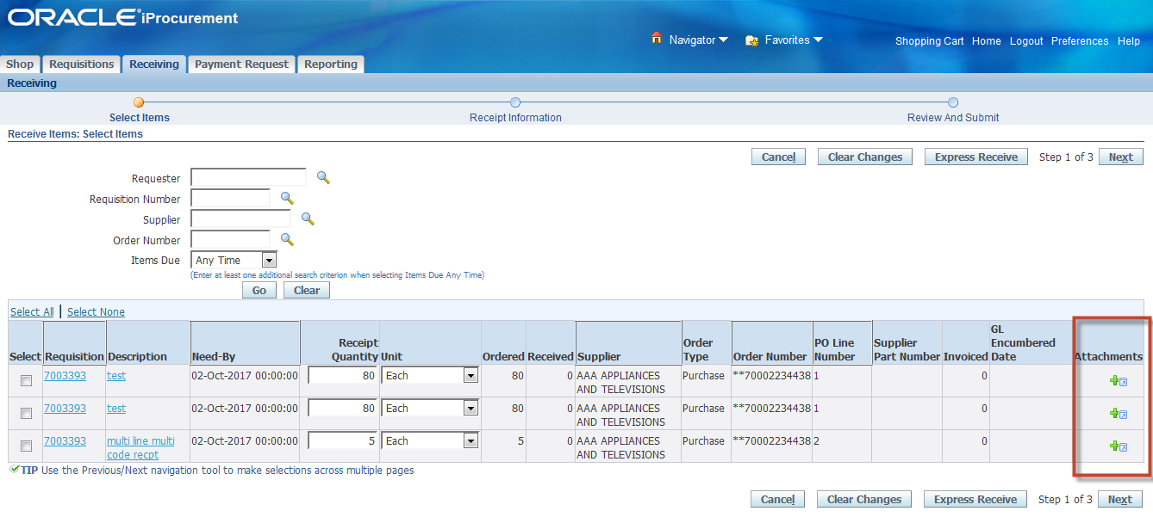
Attachments function appears on all receiving actions (Receive, correct receipt, return items)
^Note: These attachments are only attached to the receipt and cannot be seen under the requisition attachments.

Fixed Assets Change:
Asset cannot be self-assigned as its own Parent Asset any longer with this Release Rollout
In the current version of Oracle Fixed Assets, the Asset Workbench allows an asset to be self-assigned as its own Parent Asset. This function has been deemed as a bug by Oracle. With the release on the weekend of December 15th, the function of self-assignment as a Parent Asset will no longer be allowed.
End users should still assign a parent asset to the child assets. They just cannot identify an asset itself as its own parent asset.
The discontinuation of the function does not impact the FA reporting.
Where assets were self-assigned as the Parent Asset, those data points will no longer appear. Only the true parent asset will show.

Currently in Production
Asset 37107 is self-assigned itself as its own Parent Asset.


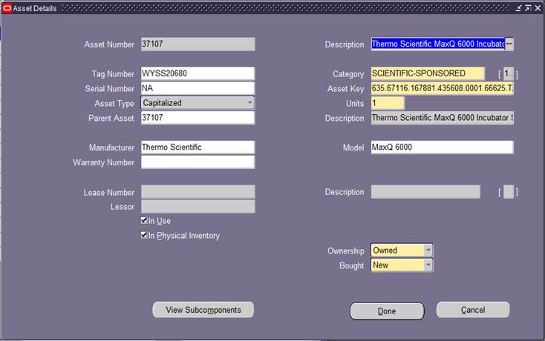

And when you click on View Subcomponents button, Asset 37107 is displayed along with its three associated child assets. Please note that Asset 37107 is clearly marked as Parent.

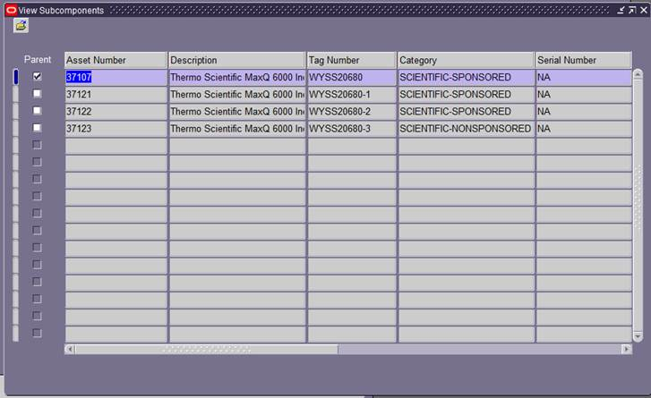

After December 15th
After December 15, an asset is not allowed to identify itself as Parent Asset. Query Asset 37107 in Asset Workbench and enter 37107 in the Parent Asset field. When clicking on the Done button, an error message will be generated “FRM-40212: Invalid value for field PARENT-ASSET.”

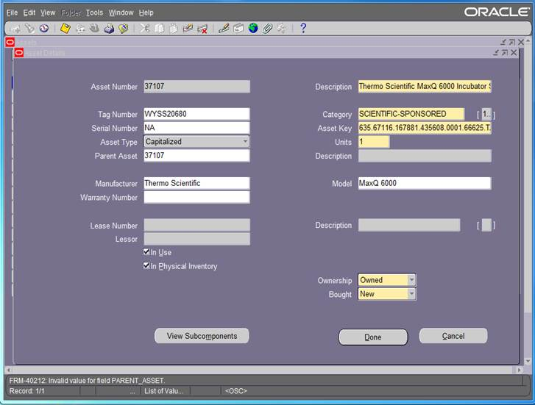

And when click on View Subcomponents button, a list of child assets associated with Parent Asset 37107 is displayed. But Parent Asset 37107 is no longer included in the list.

