Excel and Windows Settings

Purpose
This document will outline how to adjust your computer settings / permissions to use an Oracle ADI worksheet.

Table of Contents
Purpose 1
Table of Contents 1
Microsoft Excel Trust Center Permissions 2
Control Panel > Internet Properties 4
Switching Responsibilities 6
Questions? 6

Microsoft Excel Trust Center Permissions

- In Excel, select File > More > Options OR File > Options
- Select Trust Center (on the bottom left)
- Select Trust Center Settings (on the right)
- Select the following Active X Settings
  - Select Prompt me before enabling all controls with minimal restrictions
  - Safe mode (helps limit the control’s access to your computer)

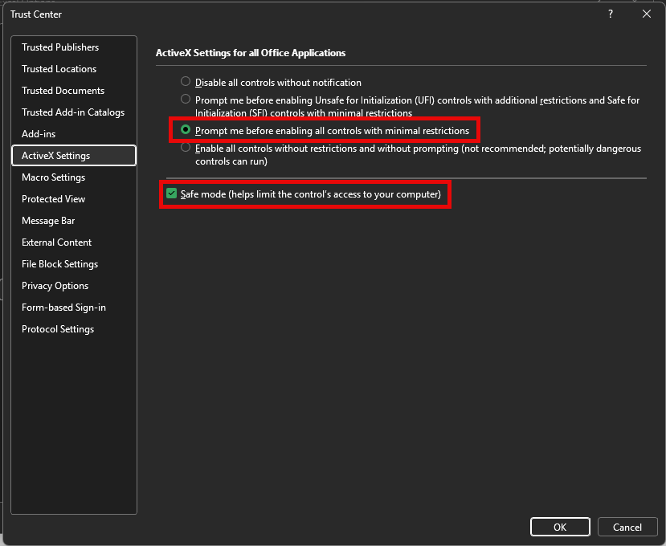

- Select Macro Settings >
  - Select Disable VBA macros with notification
  - Check the box for “Trust access to the VBA project object model”

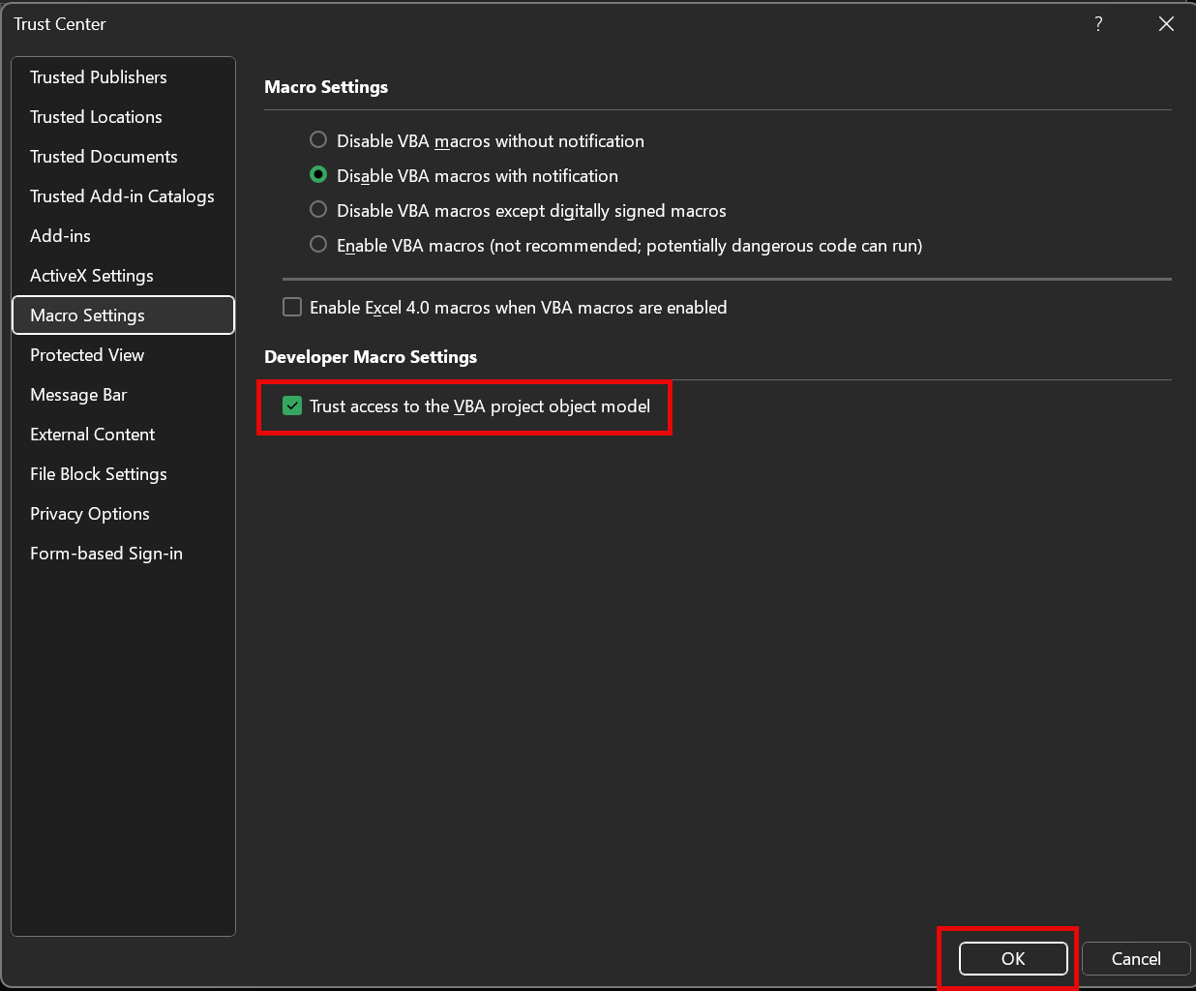

- To allow the Oracle ADI worksheet to be activated and operated efficiently, add the “Downloads” folder location. Do this by selecting Trusted Locations >
  - Click on the button: Add new location…
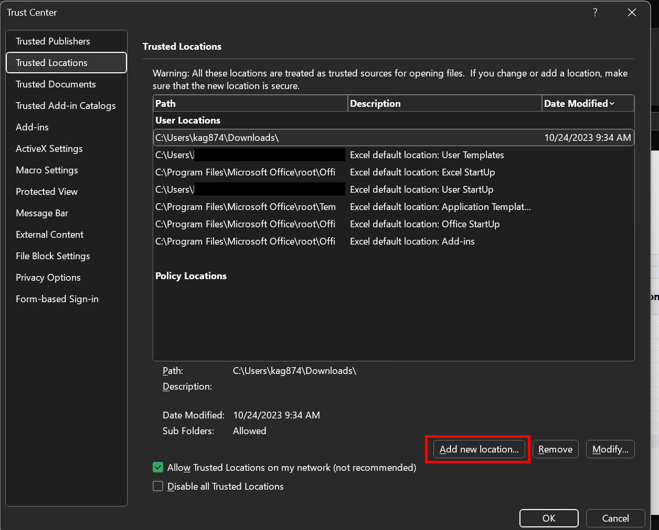
  - Select Browse > Select your “Downloads” folder on your computer > OK
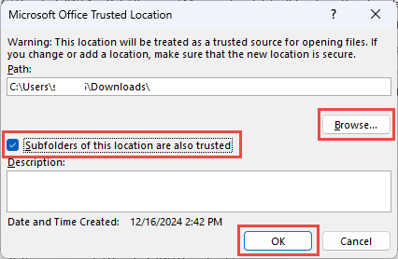
  - Check the box to trust access to the subfolders > OK
  - If other locations are used, add them and their subfolders as well
  - Click OK > OK to close the Options in Excel

Control Panel > Internet Properties
- Open the Control Panel on your computer.
- Select Internet Options

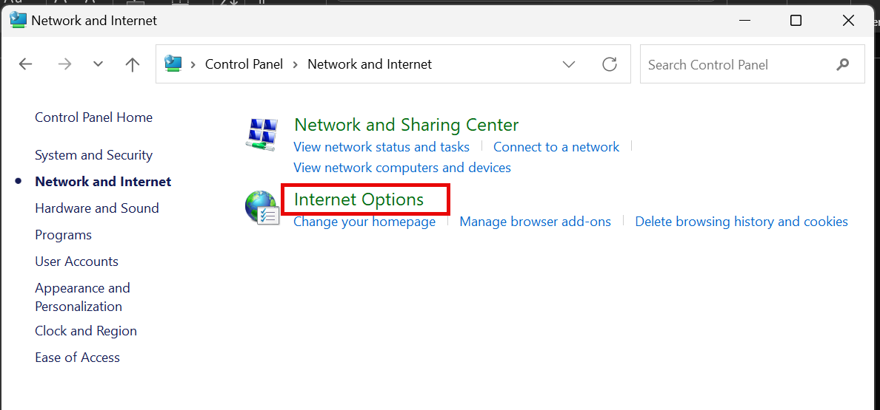

- This will open the Internet Properties window.
- Select the “Security” tab
- Click on the green checkmark labelled “Trusted sites”
- Click on the button below labeled “Sites“

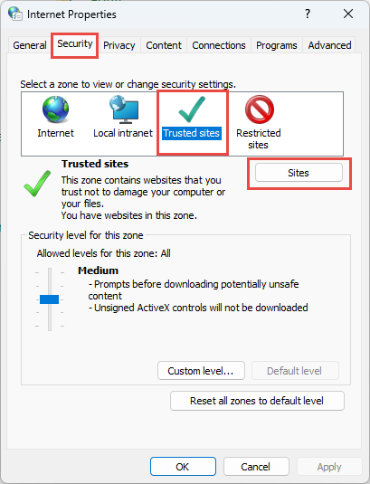

- Uncheck the box for “Require server verification (https:) for all sites in this zone”
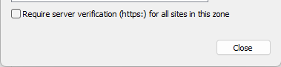
- Under “Add this website to the zone:”
  - Type in *.harvard.edu as shown below and select Add
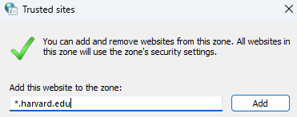
  - This will be added to the Websites:
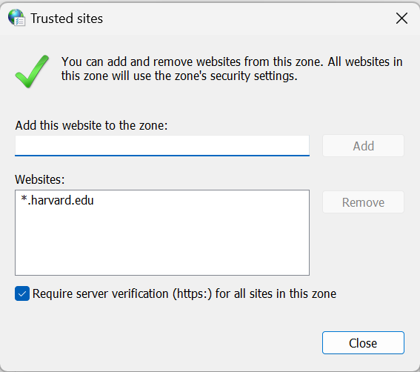
  - Re-check the box for “Require server verification (https:) for all sites in this zone”

- Select Close > Apply > OK

Switching Responsibilities
To help Oracle ADI with the Excel connection, use the switch responsibility function.

- In Excel, after opening an ADI worksheet, select the Oracle tab

- Select Switch Responsibility
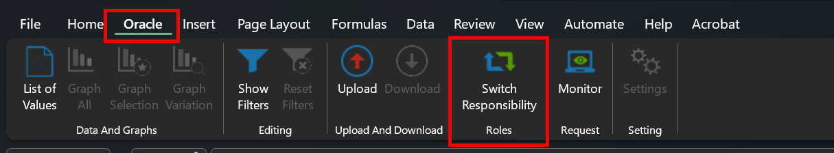
- Select your desired GL responsibility > Click Select
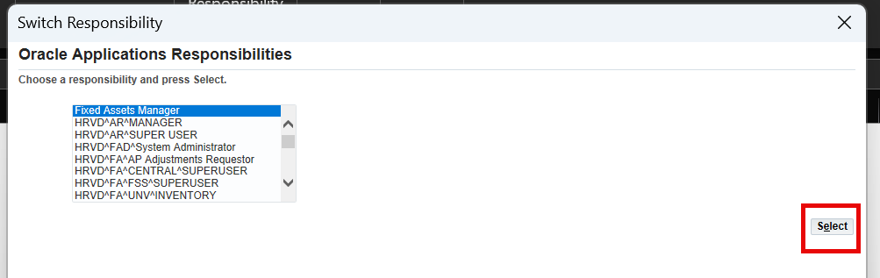
- Select Close

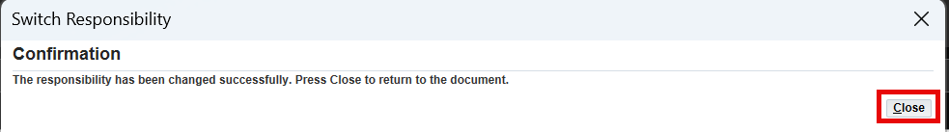

Questions?
If you have any questions, please contact the HUIT Support Center at 617-495-7777, or via email at ithelp@harvard.edu.

