As we have written to you in past publications and other communications, the HUIT Oracle Financials team has been working on the Oracle Financial Platform Improvement (OFPI) project. This phased project is helping us prepare and execute HUIT and the University to meet the goals of moving towards virtual servers on cloud based technologies for our Oracle Financial software. Some of the benefits we will gain will be cost savings to support and run our financial systems, stronger business continuity and disaster recovery, and enhanced performance and reliability as we move off of our current aging hardware. One of the first phases of this project that we have focused on is to update several of our custom applications such as PCARD and Web Reimbursement, as the outdated server technologies they run on are expiring very soon. The current language that these functions are written in is also no longer viable or supportable. HUIT has been in the process of rewriting and testing these functions to accommodate these needed changes in a supportable language (APEX) that would result in the least amount of invasive changes to the end users, and allow us to move forward to having these custom applications run on our future cloud based virtual servers.
The final changes will be rolled out in our April FINDINI Release and we wanted to bring this to your attention as you will see some noticeable visual differences within the HRVD^PCard^Reviewer and WV^Reimbursement responsibilities and menus. This April FINDINI Release will be available to users by Wednesday April 26, 2017.
In addition to the entire HRVD^PCard^Reviewer responsibility, the following items will be updated in the WV^Reimbursement Admin responsibility (highlighted in yellow):
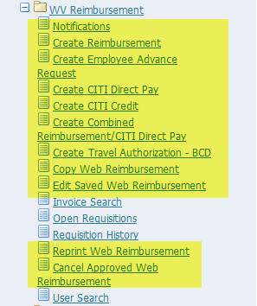

PCard Reviewer
Training Tips:
Below are a few screenshots illustrating the new look and feel, and some notes of changes you will see delivered in this April FINDINI release.
Main Screen
New Look
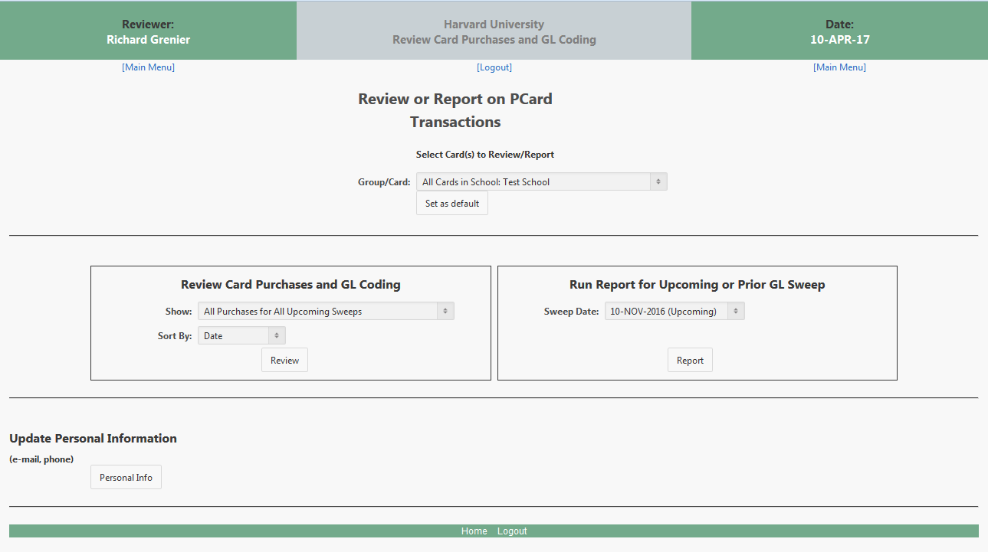
Changes:
- ‘Group/Card’ is built within the form and is now a drop down
- Slight change to the header information

Review Card Purchases and GL Coding Screen
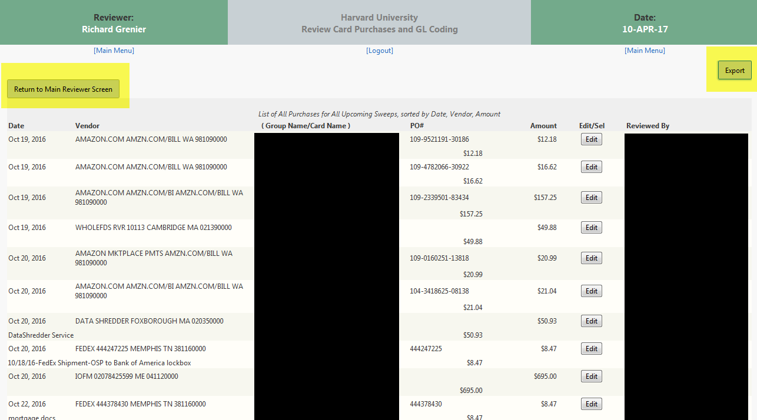
Changes:
- New ‘Export’ Function allows you to export the information on this screen into Excel
- New ‘Return to Main Reviewer Screen’ button
Edit Transactions Screen
New Look
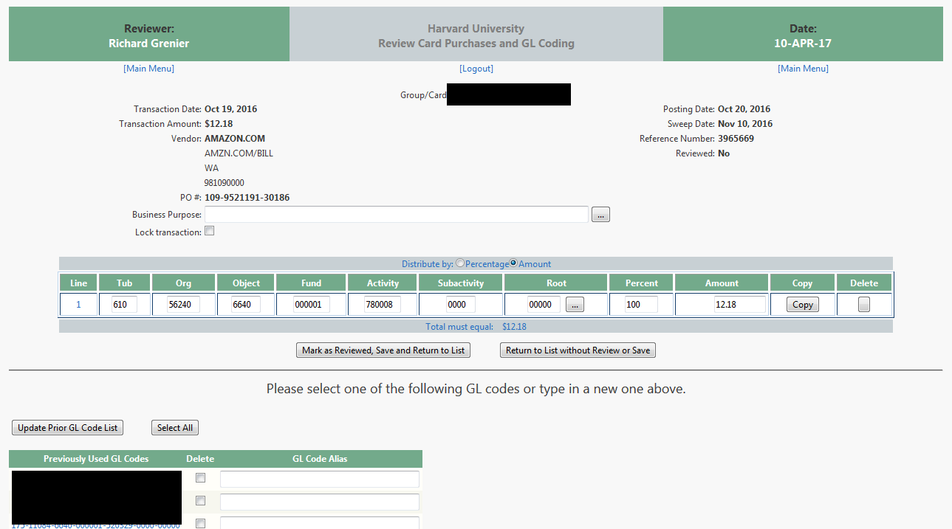
Changes:
- No major changes – just new ‘look
Run Report for Upcoming or Prior GL Sweep
New Look
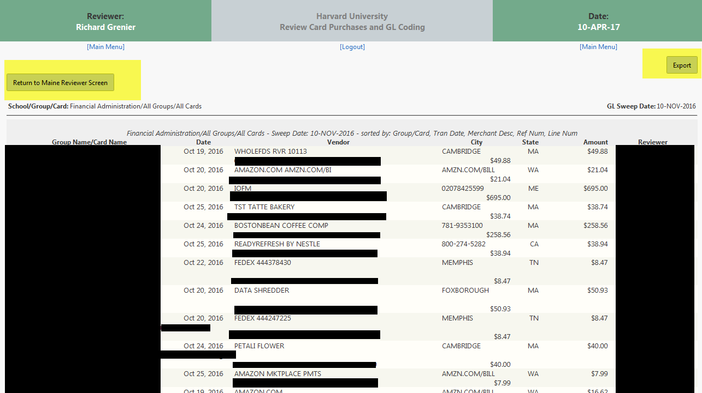
Changes:
- New ‘Export’ Function allows you to export the information on this screen into Excel
- New ‘Return to Main Reviewer Screen’ button

Web Reimbursement
Notifications
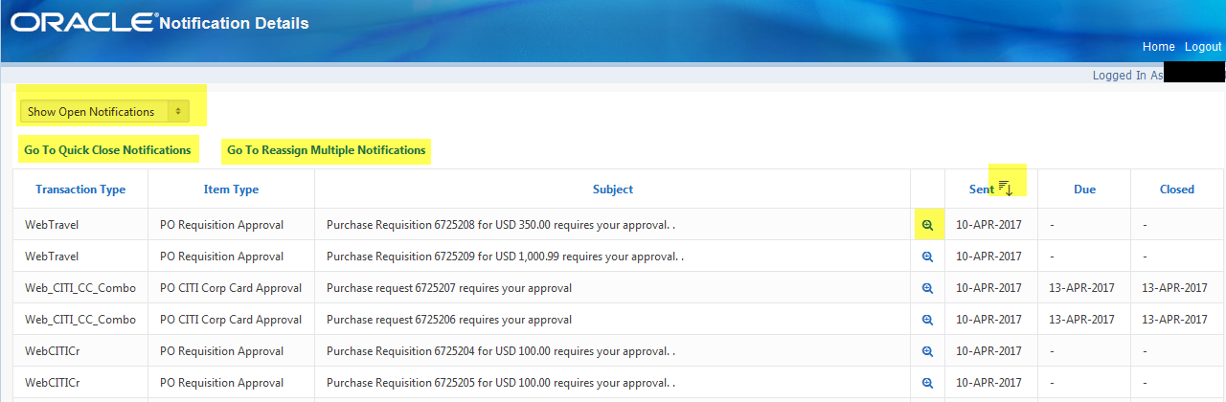
Changes:
- ‘Show Open/All Notification’ is built within the form and is now a drop down
- ‘Go to Quick Close Notifications’ is now a link to take you to the page
- ‘Go to Reassign Multiple Notifications’ is now a link to take you to the page
- Ability to Sort on Sent Date
- To ‘OPEN’ a Notification, you now need to click the ‘+’ in the spyglass and not the Subject line

Notifications Detail
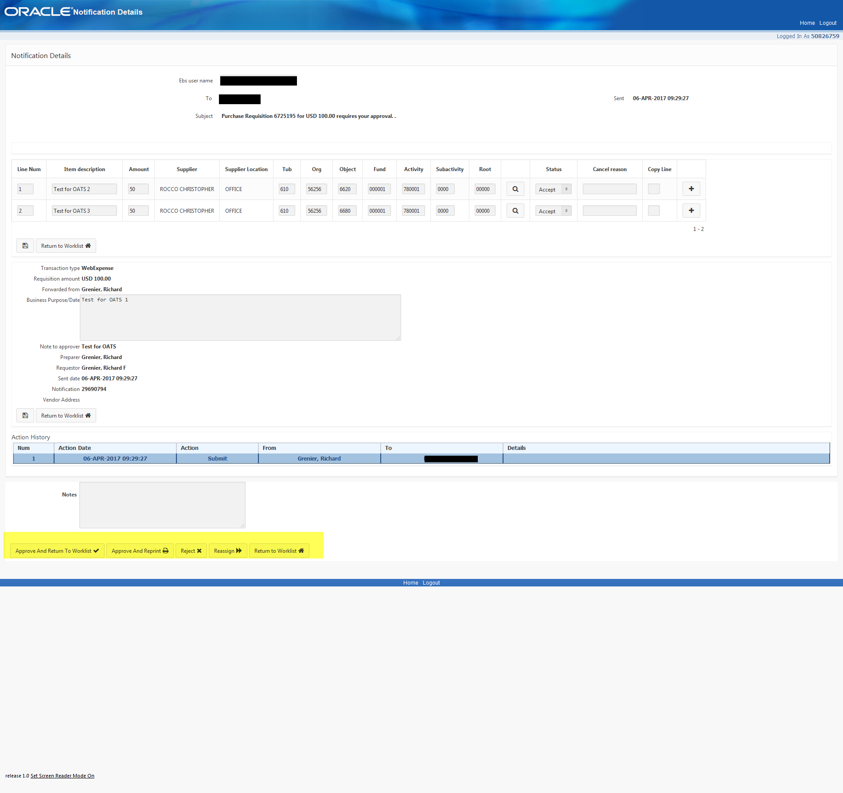
Changes:
- New look
- Functionality basically still the same in forms (can change coding, add/remove lines, etc.)
- Reassign function is a new ‘search’ to populate the information
- Please note that a CITI COMBO may look a little different, as it does in todays form.

Create Reimbursement
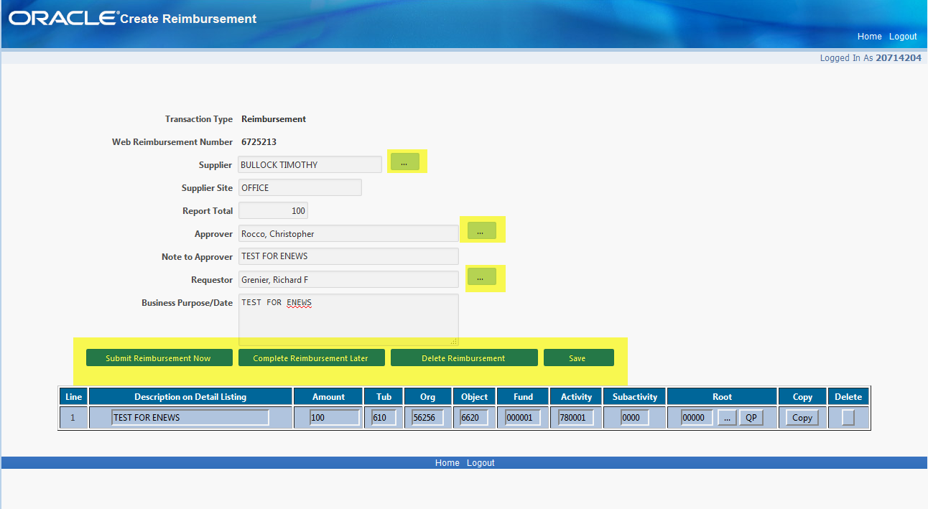
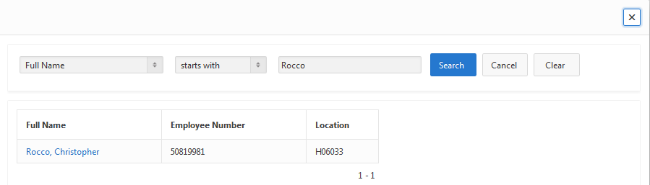
Changes:
- New ‘look’
- Supplier/Approver/Requestor search functionality more mainstream
- Submission buttons are now located between the header information and the line information

Create Employee Advance Request
New Look
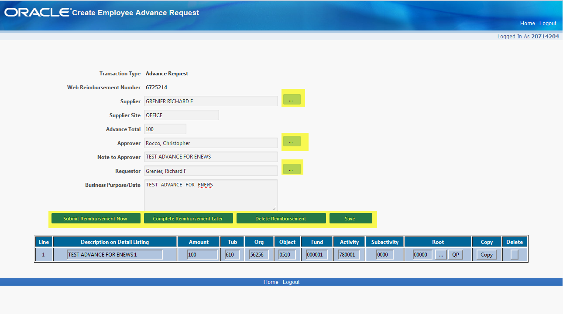

Changes:
- New ‘look’
- Supplier/Approver/Requestor search functionality more mainstream
- Submission buttons are now located between the header information and the line information

CITI Direct Pay
New Look
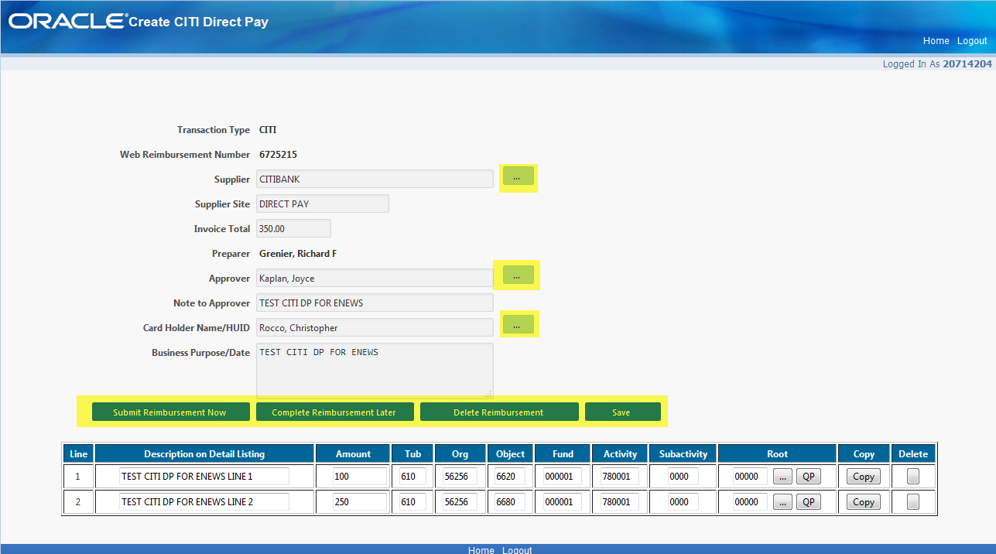

Changes:
- New ‘look’
- Supplier/Approver/Requestor search functionality more mainstream
- Submission buttons are now located between the header information and the line information

CITI Credit
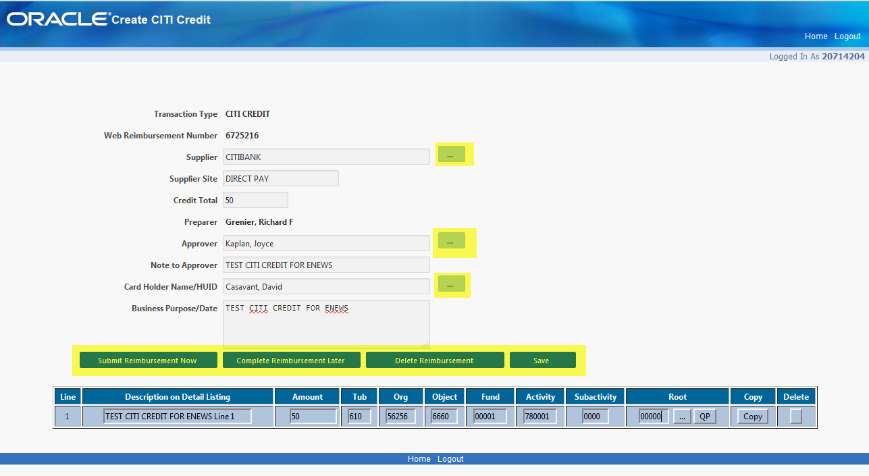
Changes:
- New ‘look’
- Supplier/Approver/Requestor search functionality more mainstream
- Submission buttons are now located between the header information and the line information

Create Combined Reimbursement/CITI Direct Pay
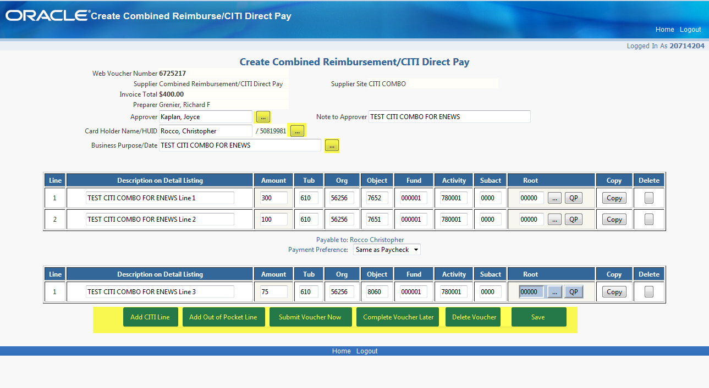
Changes:
- New ‘look’
- Supplier/Approver/Requestor search functionality more mainstream
- Submission buttons are located BELOW the line information

Create Travel Authorization – BCD
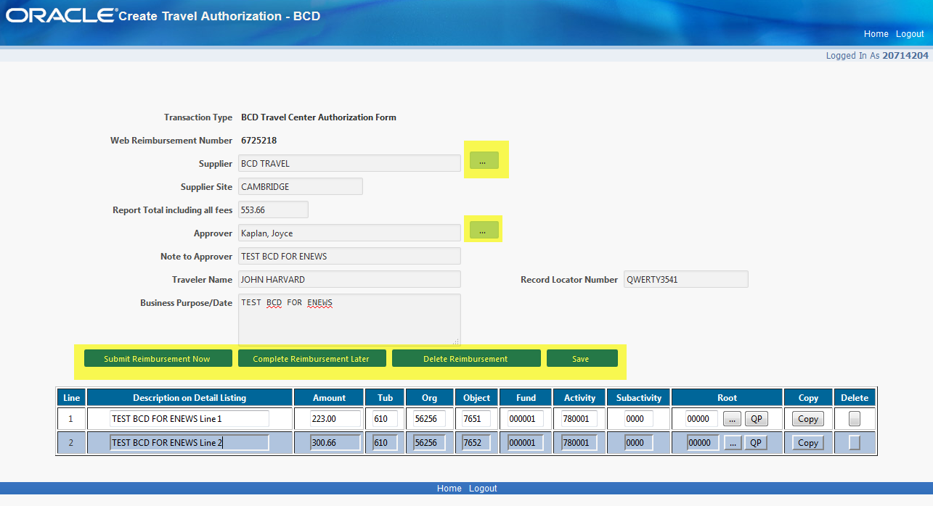
Changes:
- New ‘look’
- Supplier/Approver/Requestor search functionality more mainstream
- Submission buttons are now located between the header information and the line information

Copy Web Reimbursement
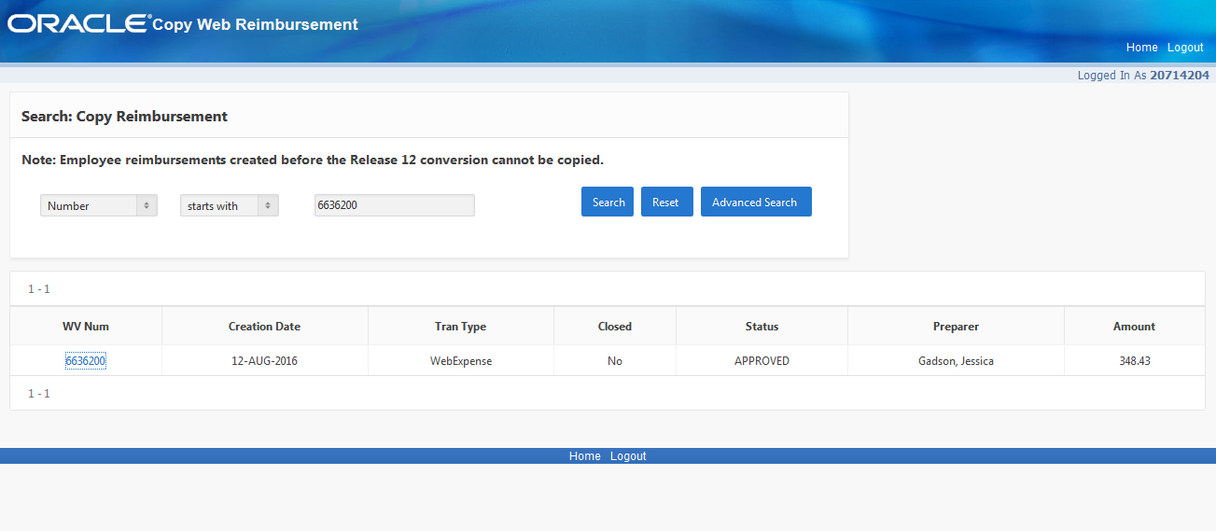
Changes:
- New ‘look’

Edit Saved Web Reimbursement
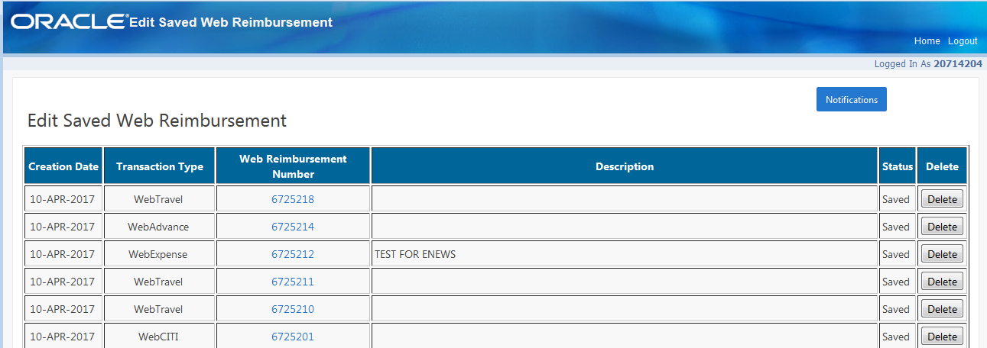
Changes:
- New ‘look’

Reprint Web Reimbursement
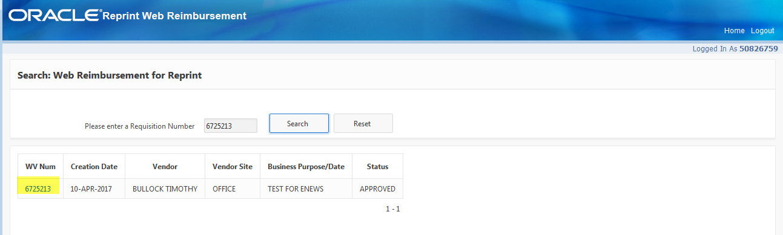
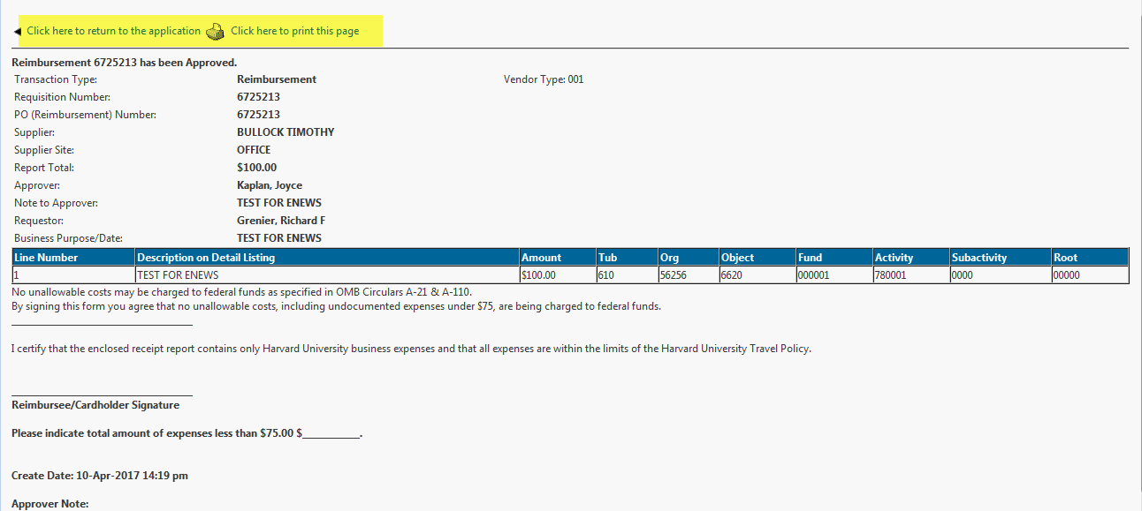

Changes:
- New ‘look’

Cancel Approved Web Reimbursement
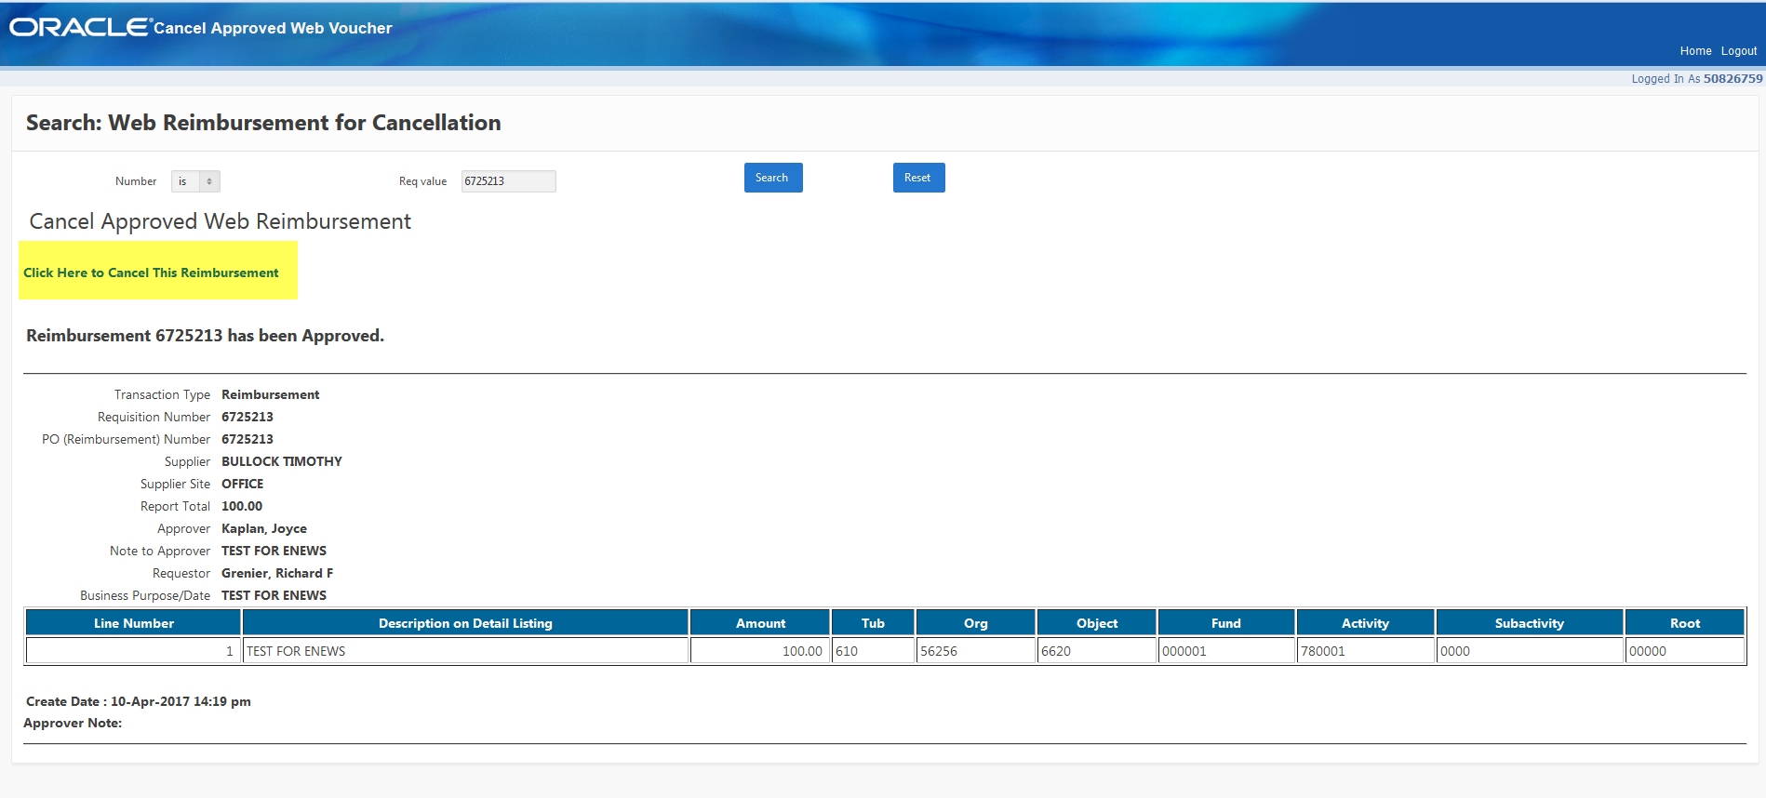
Changes:
- New ‘look’

Printing or Copying Web Reimbursements within a Requisition
The function that allows you to Copy a Reimbursement while in the form, as well as the Print function is now located at the TOP of the form after you have sent the requisition for approval. Please note the ‘Print’ button will open your open your computers normal print function.
We are aware that with the different browsers each individual uses, that the printed form will look different in each browser type and version (IE, Firefox, Etc.). We will be putting in a fix to this in the early summer to convert these into a PDF before printing so they will be consistent in the future.

