Deleting Cookies in Internet Explorer IE 11
Action: Login to Oracle Financials via “Harvard Key”.
After authenticating via Harvard Key IF YOU GET AN ERROR as shown in screenshot below then please follow the rest of the screenshots to delete cookies in Internet Explorer.
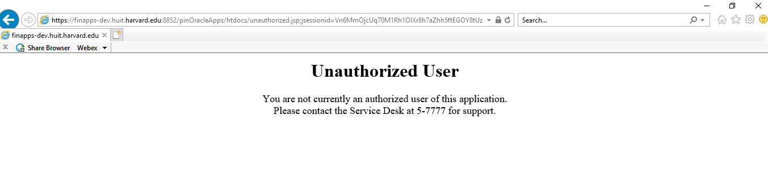
Steps to Delete Cookies in IE
Screen 1: Opening Cookies section in IE
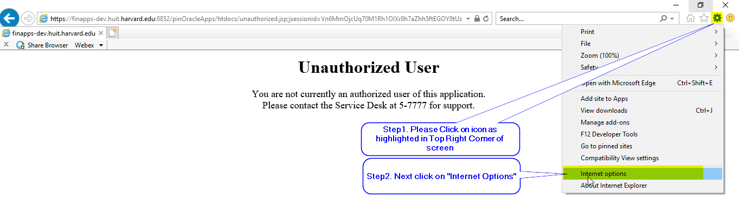
Screen 2: Opening Cookies section in IE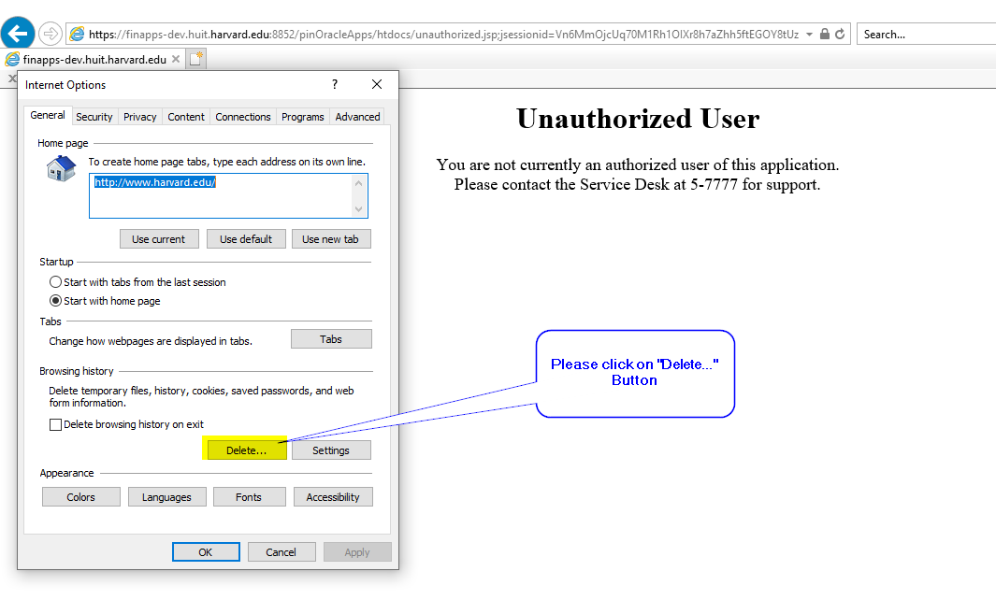
Screen 3: Final step “Removing Cookies” from IE
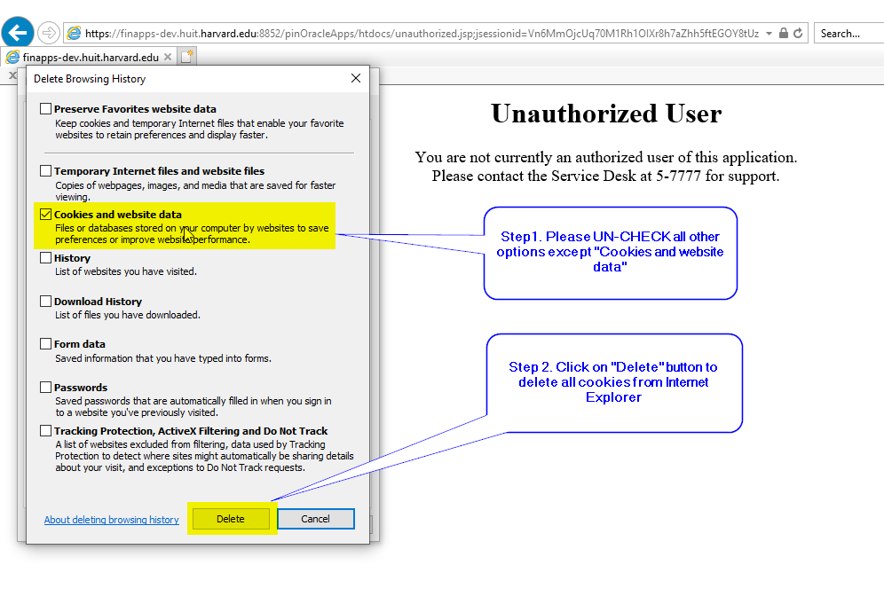

Screen 4: You will get message “Internet Explorer has finished deleting the selected browsing history”
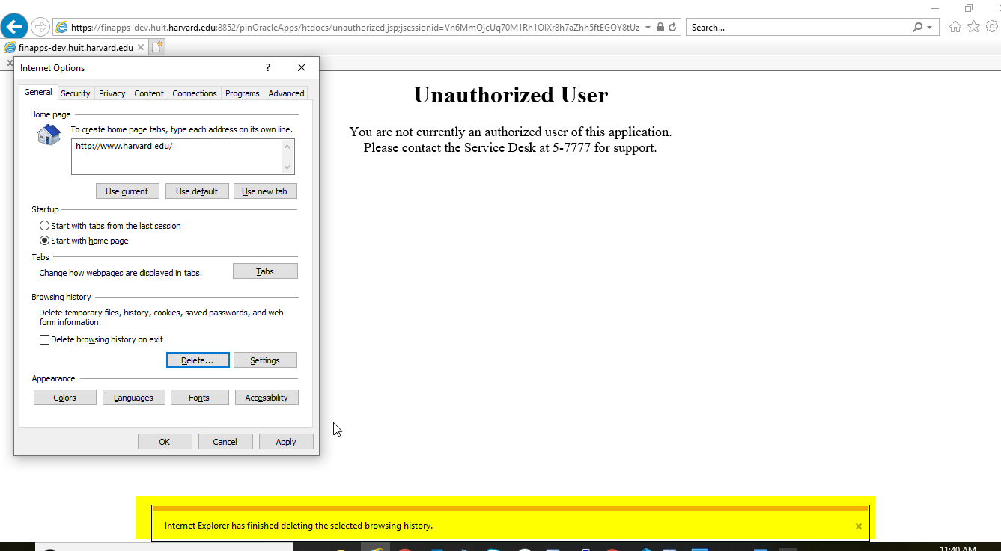

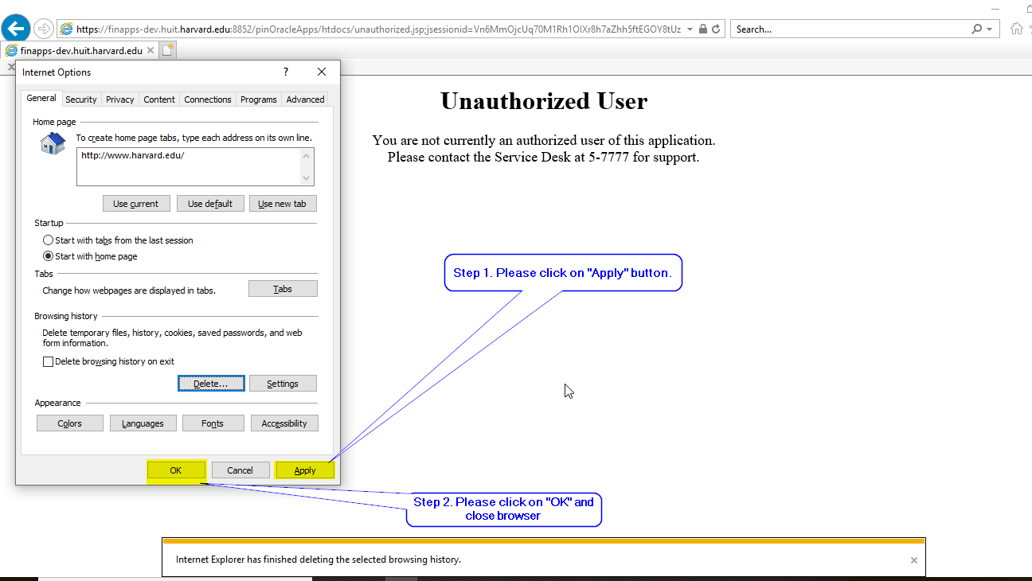
Please close Internet Explorer and open it again to login to “Oracle Financials” via Harvard Key.

