Clearing of Cookies in GOOGLE CHROME
Action: Login to Oracle Financials via “Harvard Key”.
After authenticating via Harvard key IF YOU GET AN ERROR as shown in screenshot below then please follow the rest of the screenshots to delete cookies in Google Chrome.
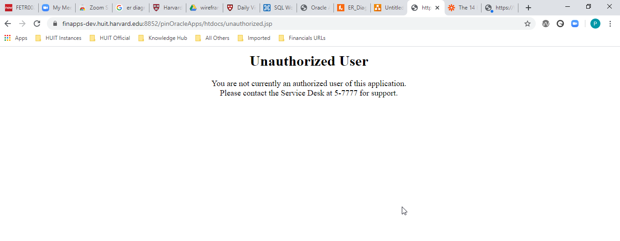

Steps to Delete Cookies in Chrome
Screen 1: Opening Cookies section in Chrome
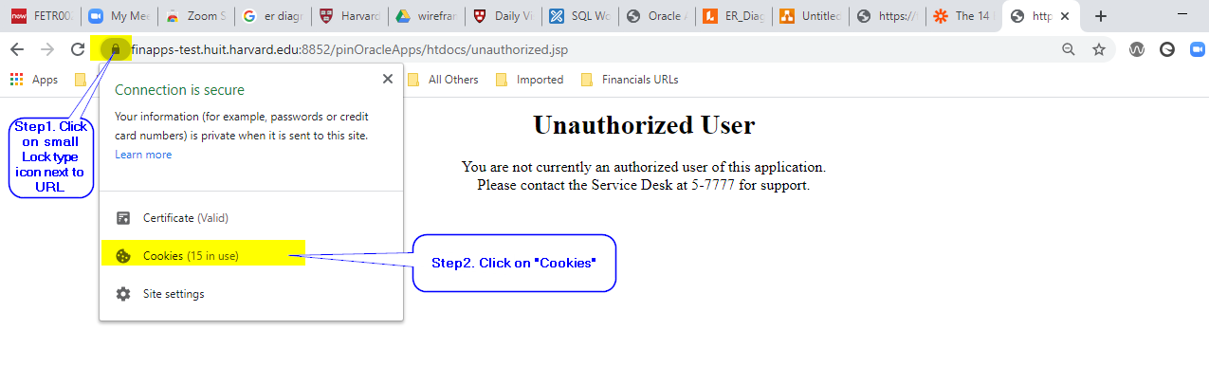

Screen 2: Opening Cookies section in Chrome
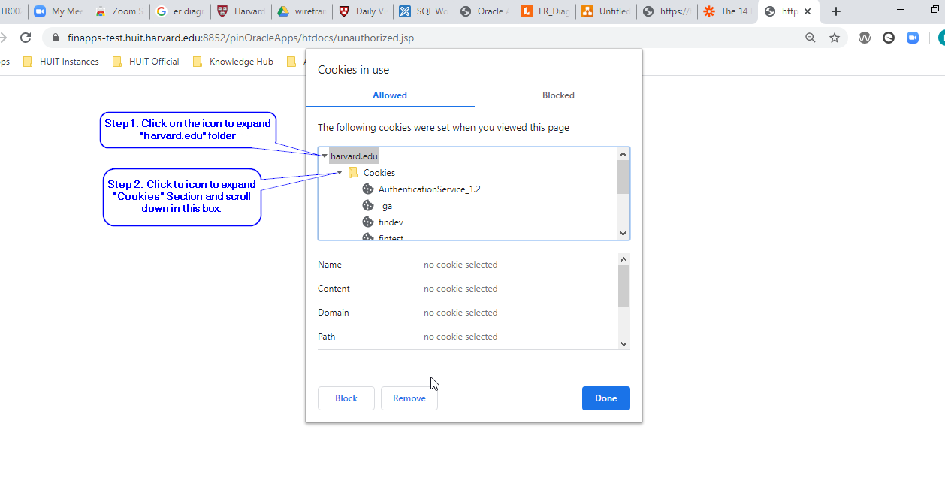
Screen 3: Final step “Removing Cookies” from chrome
Please close Chrome and open it again to login to “Oracle Financials” via Harvard Key.
